**Technical assessment for**

**Public Transit**

Sector: Transport

Agency Level: Individual, Community

Keywords: Transport Efficiency, Urban Planning, Public Transportation, Buses, BRT, Metros, Tram, Informal Transport, Commuter Rail, Collective Transport, Rapid Transit, Mass Transit

Book Edition 3 (August 2021)

**Prepared by:**

Heather Jones, Research Fellow

Demetrios Papaioannou, Research Fellow

Ryan Allard, Senior Fellow



27 GATE 5 RD., SAUSALITO, CA 94965 [info@drawdown.org](mailto:info@drawdown.org) [www.drawdown.org](http://www.drawdown.org)

Table of Contents

List of Figures III

List of Tables IV

Acronyms and Symbols Used V

Executive Summary VI

1 Literature Review 8

1.1 State of Public Transit 8

1.1.1 Different Types of Public Transit Modes 10

1.1.2 Public Transit and Climate Change 15

1.2 Adoption Path 15

1.2.1 Current Adoption 15

1.2.2 Trends to Accelerate Adoption 17

1.2.3 Barriers to Adoption 18

1.2.4 Adoption Potential 18

1.3 Advantages and disadvantages of Public Transit 22

1.3.1 Similar Solutions 22

1.3.2 Arguments for Adoption 23

1.3.3 Additional Benefits and Burdens 24

2 Methodology 24

2.1 introduction 24

2.2 Data Sources 26

2.2.1 Total Addressable Market 27

2.2.2 Adoption Projections 27

2.2.3 Variable Inputs 27

2.3 Total Addressable Market 28

2.4 Adoption Scenarios 29

2.4.1 Reference Case / Current Adoption 29

2.4.2 Project Drawdown Scenarios 30

2.5 Inputs 32

2.5.1 Climate Inputs 32

2.5.2 Financial Inputs 33

2.5.3 Technical Inputs 36

2.6 Assumptions 37

2.7 Integration 37

2.8 Limitations/Further Development 39

3 Results 40

3.1 Adoption 40

3.2 Climate Impacts 41

3.3 Financial Impacts 43

4 Discussion 44

4.1 Limitations 47

4.2 Benchmarks 47

5. References 48

5 Glossary 57

# List of Figures

Figure ‎1.1: Life-cycle greenhouse gas emissions of urban transport modes (ITF/OECD, 2020) 9

Figure ‎1.2: Types of buses (UITP, 2019a) 10

Figure ‎1.3:Global bus fleet composition (UITP, 2019a) 11

Figure ‎1.4:Type of energy consumed by global bus fleet (UITP, 2019a) 12

Figure ‎1.5: BRT Evolution (BRT Data, 2021) 12

Figure ‎1.6: Metro system opening by decade (UITP, 2018) 13

Figure ‎1.7: LRT system opening (UITP, 2019b) 14

Figure ‎1.8 Example Public Transit Systems. 15

Figure ‎3.1 World Annual Adoption 2020-2050 41

Figure ‎3.2 World AnnualGreenhouse Gas Emissions Reduction 43

Figure ‎3.3 Operating Costs Over Time 44

# List of Tables

Table ‎1.1 Current Global Modal Share and Adoption of Public Transit in billion pkm 16

Table ‎1.2 Urban Passenger Mode Comparison 24

Table ‎2.1 Global and Regional TAM, in billion pkm 29

Table ‎2.2 Climate Inputs 33

Table ‎2.3 Financial Inputs for Conventional Technologies 35

Table ‎2.4 Financial Inputs for Solution 36

Table ‎2.5 Technical Inputs 37

Table ‎3.1 World Adoption of the Solution 40

Table ‎3.2 Climate Impacts 41

Table ‎3.3 Impacts on Atmospheric Concentrations of CO2-eq 42

Table ‎3.4 Financial Impacts 43

Table ‎4.1 Benchmarks 47

# Acronyms and Symbols Used

* **BRT** – Bus Rapid Transit
* **COP** – Conference of the Parties (Climate Change Conference)
* **GHG** – Greenhouse Gas
* **GT** – Gigatons
* **ICE** – Internal Combustion Engine
* **ICT** – Information and Communication Technology
* **ICCT** – International Council on Clean Transport
* **IEA** – International Energy Agency
* **IPCC** – Intergovernmental Panel on Climate Change
* **ITDP** – Institute for Transportation and Development Policy
* **ITF** – International Transport Forum
* **PDS** – Project Drawdown Scenario
* **PKM** – Passenger-kilometer (1 passenger moved 1 kilometer)
* **REF** – Reference Scenario (of Project Drawdown)
* **TAM** – Total Addressable Market
* **TNC** – Transportation Network Companies
* **UITP** – International Association of Public Transport (in French)
* **VKM** – Vehicle-kilometer (1 vehicle moving 1 kilometer)

# Executive Summary

Public transit, or public transport, refers to all urban passenger modes that have the ability to transport a large number of people. Public transit is a climate solution (NASEM, 2021) as result of the GHG savings that come from both transportation and land use efficiency. Transportation efficiency is the emissions reduced by passengers using public transit instead of personal vehicles. Other benefits include less energy use and improved air quality. The benefits to society that come from having public transit available are land use efficiencies such as shorter and fewer personal vehicle trips and more walking and bicycle trips.

Public transit is a good mode choice for urban passenger transit. It is an important component of the mix of mode choices and has the ability to shift use from modes with higher emissions. While the costs associated with public transit are incurred by several levels of agency, this analysis evaluates costs to the user, not the builder or operator. In this respect, it is one of the most cost-effective modes for individuals. Public transit emits significantly less than cars of all kinds. By pkm, metro is one of the least polluting modes of transport, and with many buses now electric there are additional gains to be had. In congestion, which is common in the urban passenger market that is modeled, public transit can go as fast or faster than cars (Altieri et al., 2020) especially if there is dedicated infrastructure. Further, this solution does not contribute nearly as much to congestion (AlKheder, 2021) as do cars, including Transportation Network Companies (TNCs) such as Uber, Lyft and Didi (Diao et al., 2021).

The Reduction and Replacement Solutions (RRS) model was used to evaluate the impacts of increased public transit usage around the world from 2014 to 2060 with primary results being reported here for the period 2020-2050. The current adoption of public transit was found to be about 30% of the total addressable market (TAM) globally with higher adoption rates in Eastern Europe, the Middle East and Africa due to the use of light rail and bus transit in these regions.

The model is based on three main sources for public transit statistics: International Transportation Forum Transport Outlook (ITF), the Institute for Transportation and Development Policy’s (ITDP) Global High-Shift Cycling report and the International Energy Agency´s (IEA) Energy Technology Perspectives. These three sources yield an estimated current adoption of 9,673 billion passenger-kilometers (PKM) of public transit use around the world. The model then projects public transit PKM to increase to over 14,530 billion PKM by 2050.

The results of the analysis show that public transit represents a net financial benefit for the individuals who use it, as well as a net greenhouse gas (GHG) benefit for the globe. Given the projections described above and the emissions factors of different travel modes, the predicted increase in the use of public transit over current levels could prevent the release of 27.77 cumulative gigatons of carbon dioxide-equivalents and save consumers $90,614 billion over the period studied. The increasing electrification of bus fleets will cause these benefits to grow.

# Literature Review

Globally, transport of people and goods produces 9.5 gigatons (Gt) of carbon dioxide-equivalent (CO2-eq) greenhouse gas emissions annually, equivalent to 23 percent of *energy-related* emissions, or 14 percent of *all* emissions (IEA, 2017)[1]. In individual countries, where transport is based on high-emission modes, transport can account for much higher shares. The sources of those 9.5 Gt are chiefly from cars and light trucks, which account for over 50% of all transport emissions. Heavy freight trucks and buses contribute an additional 26% and air transport and shipping each generate 10% of global transport emissions (IEA, 2017). Growth rates in emissions for some subsectors like air transport and shipping are very high, so the Transport Sector requires special focus to keep emissions from ballooning out of control, as some projections indicate. Transport, however, is a service derived from economic growth. Research shows that wealthier people travel more, locally and internationally, and demand more goods and services. So, as a country develops economically, movement of people and goods increases. Solutions generally can be classified using the “*avoid-shift-improve*” framework: *avoid* travel altogether, *shift* travel to low-carbon modes or *improve* modes to generate lower emissions.

## State of Public Transit

Public transit, or public transport, refers to all urban passenger modes that have the ability to transport a large number of people. A further distinction can be made through the vehicle ownership, the vehicle is almost never owned by the passenger. Public transit includes a variety of modes, the most common being bus, metro, tram / light rail, commuter rail, and BRT (Bus Rapid Transit). These modes, assuming a ridership of more than 3 people per vehicle, have fewer greenhouse gas (GHG) emissions compared to private vehicle modes (ITF/OECD, 2020).

Transportation, driven by rapid growth in car use, has been the fastest growing source of CO2 in the world. As a more energy-efficient solution for urban mobility (see Figure 1.1), public transit—together with walking and cycling—is competing with carbon-intensive private motor vehicles (mainly private cars) in the urban transport market. **Modal shift** from cars to public transit modes is one of the main measures to reduce the GHG emissions of transport systems.

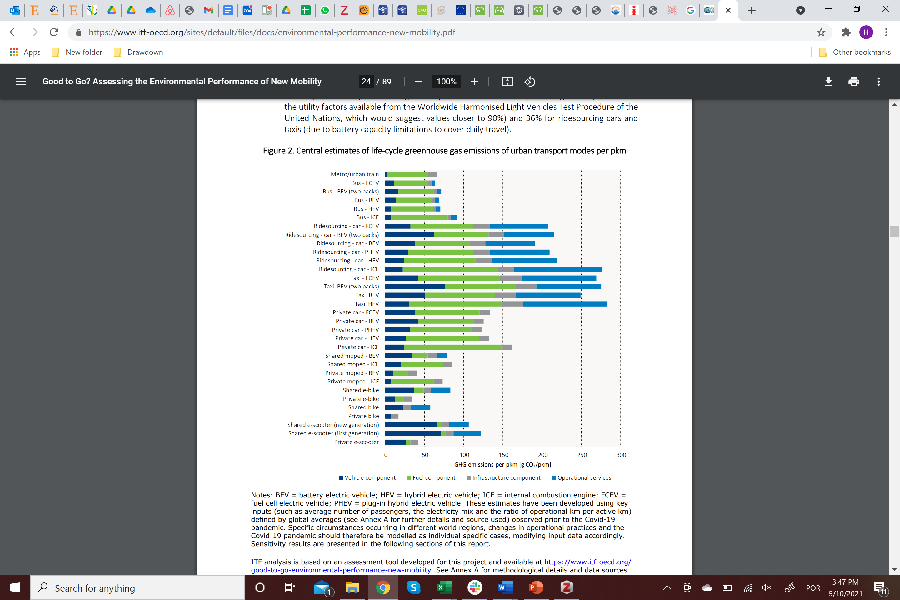

Figure ‎1.1: Life-cycle greenhouse gas emissions of urban transport modes (ITF/OECD, 2020)

Previous studies show significant greenhouse gas emission savings by use of public transit, which offers a low emissions alternative to driving (AlKheder, 2021; Byrne et al., 2021).

### Different Types of Public Transit Modes

As mentioned earlier, public transit consists of a sum of different transport modes, each with different characteristics. Here the main types of public transit modes are briefly presented.

#### Bus – Minibus – BRT

Buses are the most common public transit mode globally (ITF, 2021). With the exception of Bus Rapid Transit (BRT), they operate within normal road traffic, yet are sometimes aided by exclusive lanes or signal priority. BRTs always have exclusive lanes and signal priority (Prodan, 2020). The difference between minibuses and normal buses is only on the size and capacity. Minibuses are mostly used in the developing world, and in many developing cities they provide the only public transit option for residents. These differ from all other public transit systems listed here since they are often owned by individuals rather than any government agency or concessionaire, may be unregulated, grow quickly and organically as the need arises, at least until they are replaced by more formal systems. These can be found in Brazil, Kenya, Ethiopia, Nigeria, Indonesia and many other countries. Most buses worldwide operate with liquid fuel engines, mostly diesel. In the last decades electric and hybrid buses have started to penetrate the market and are gaining market share.

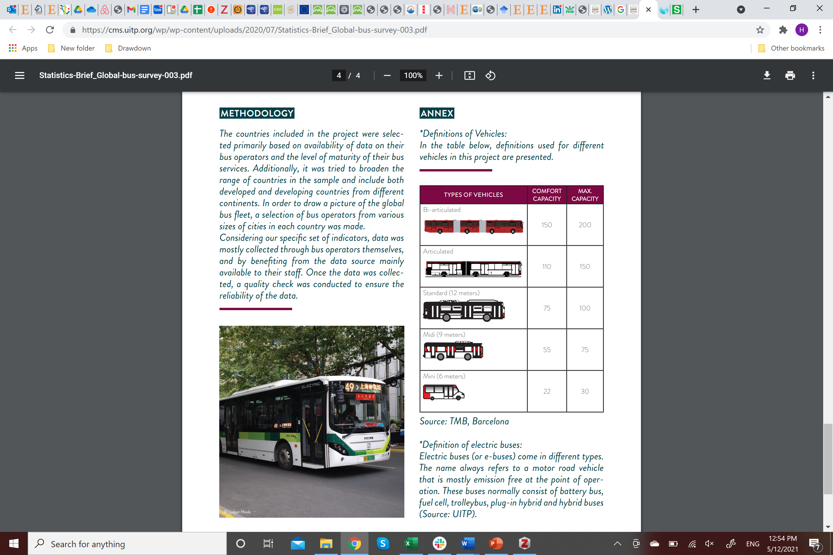

Figure ‎1.2: Types of buses (UITP, 2019a)

Most of the bus fleet (68%) are regular standard 12-meter buses. Articulated buses are 12% of the fleet. The remaining 20% are midibuses, minibuses, double-decker and trolleybuses. The share varies by country. For example, Argentina, Denmark, Finland, Japan, Nigeria, and Republic of Korea each have more than 90% of the fleet as standard buses (UITP, 2019a).

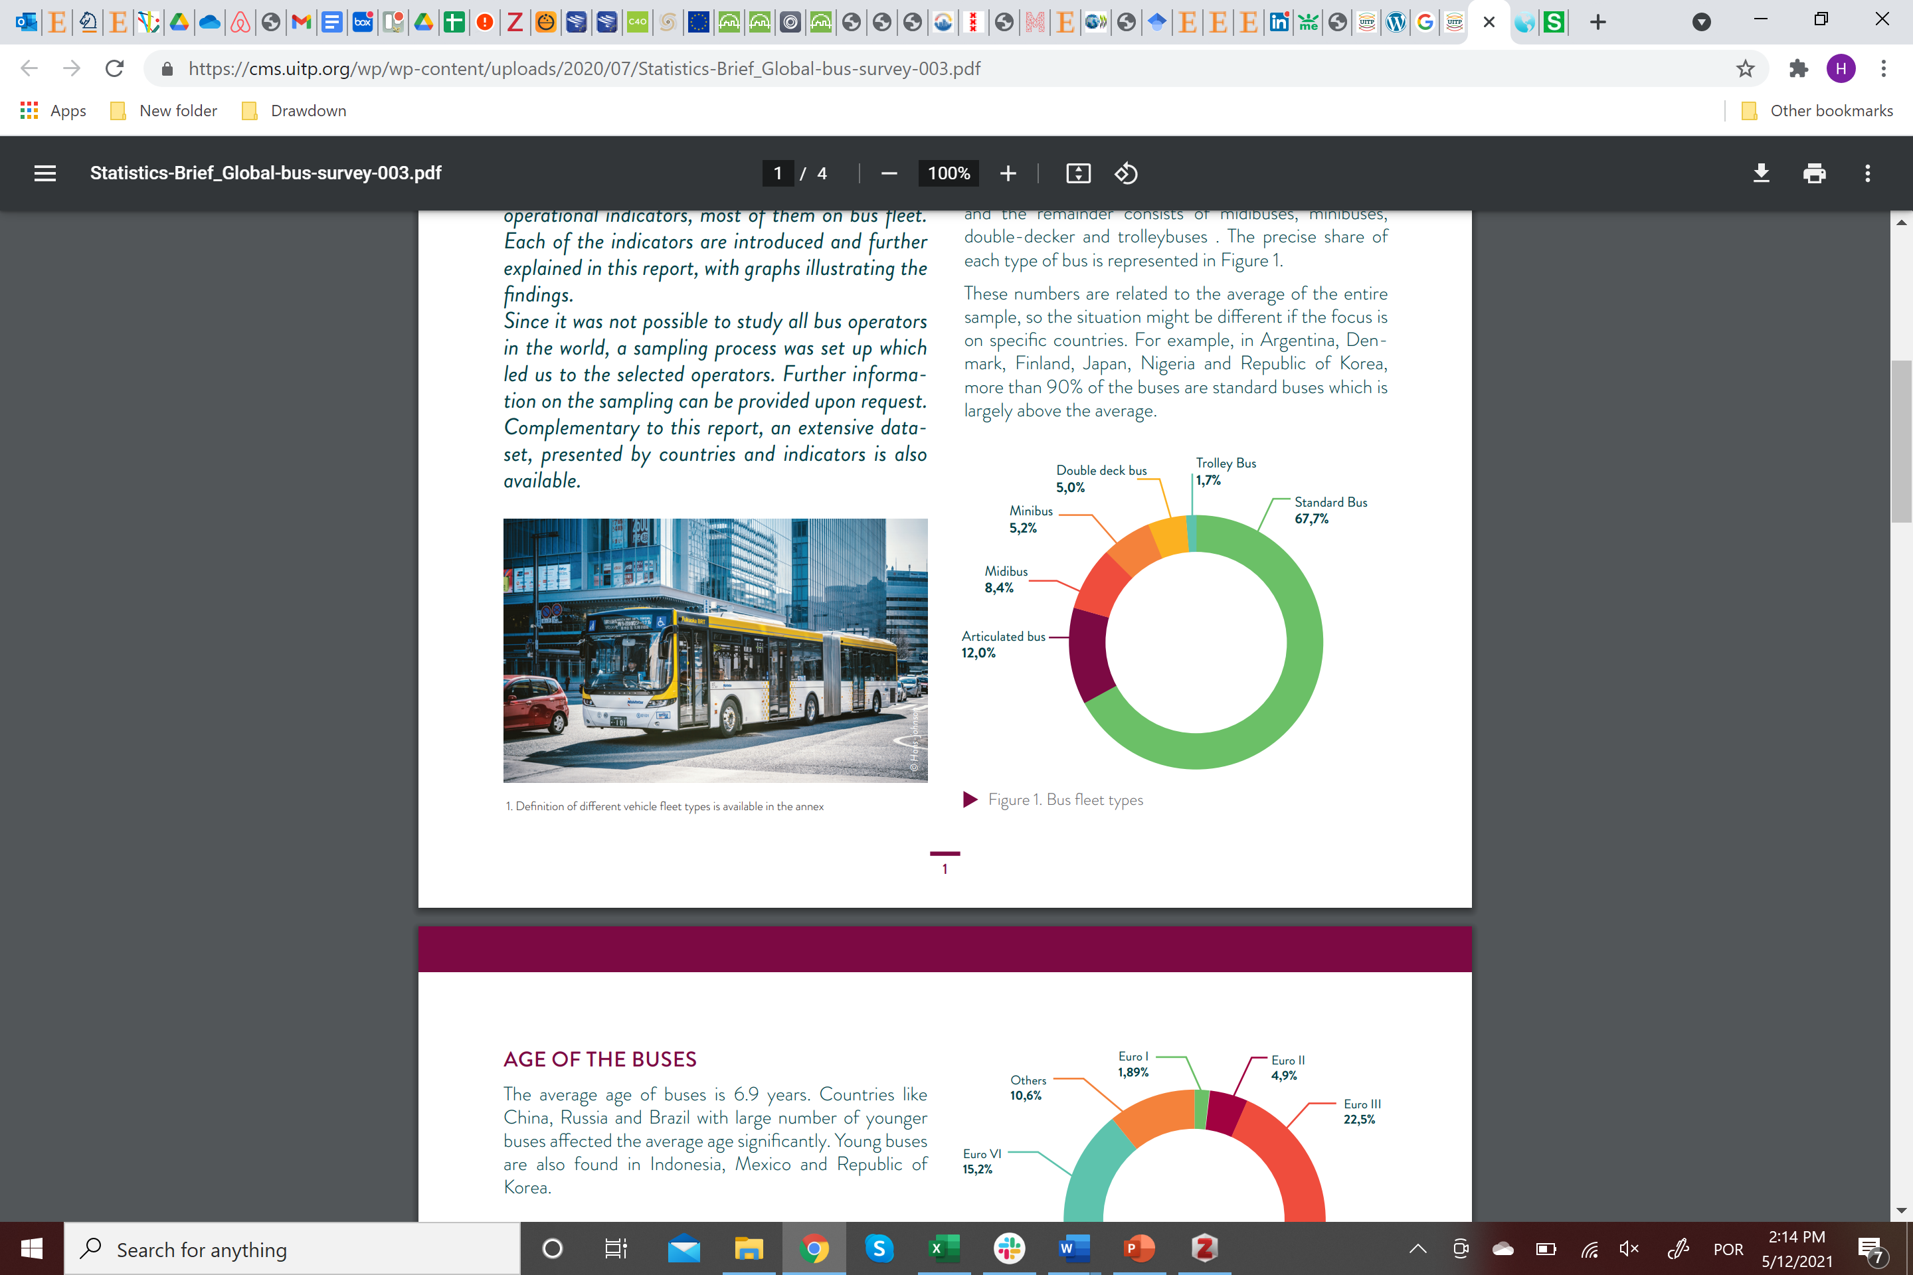

Figure ‎1.3:Global bus fleet composition (UITP, 2019a)

While diesel buses have the largest share of the bus fleet, electric buses are rapidly gaining share in many countries. China and Europe are leading the way. China has a new energy bus program and by far has the largest share (57%) of global e-buses. In Europe, 25 cities had e-bus plans for 2020. E-buses in Romania (22%), France (18%) and the United Kingdom (18%) have large shares of the bus fleet (UITP, 2019a). Regarding alternative fuels, most (98%) of the bus fleet use CNG (UITP, 2019a).

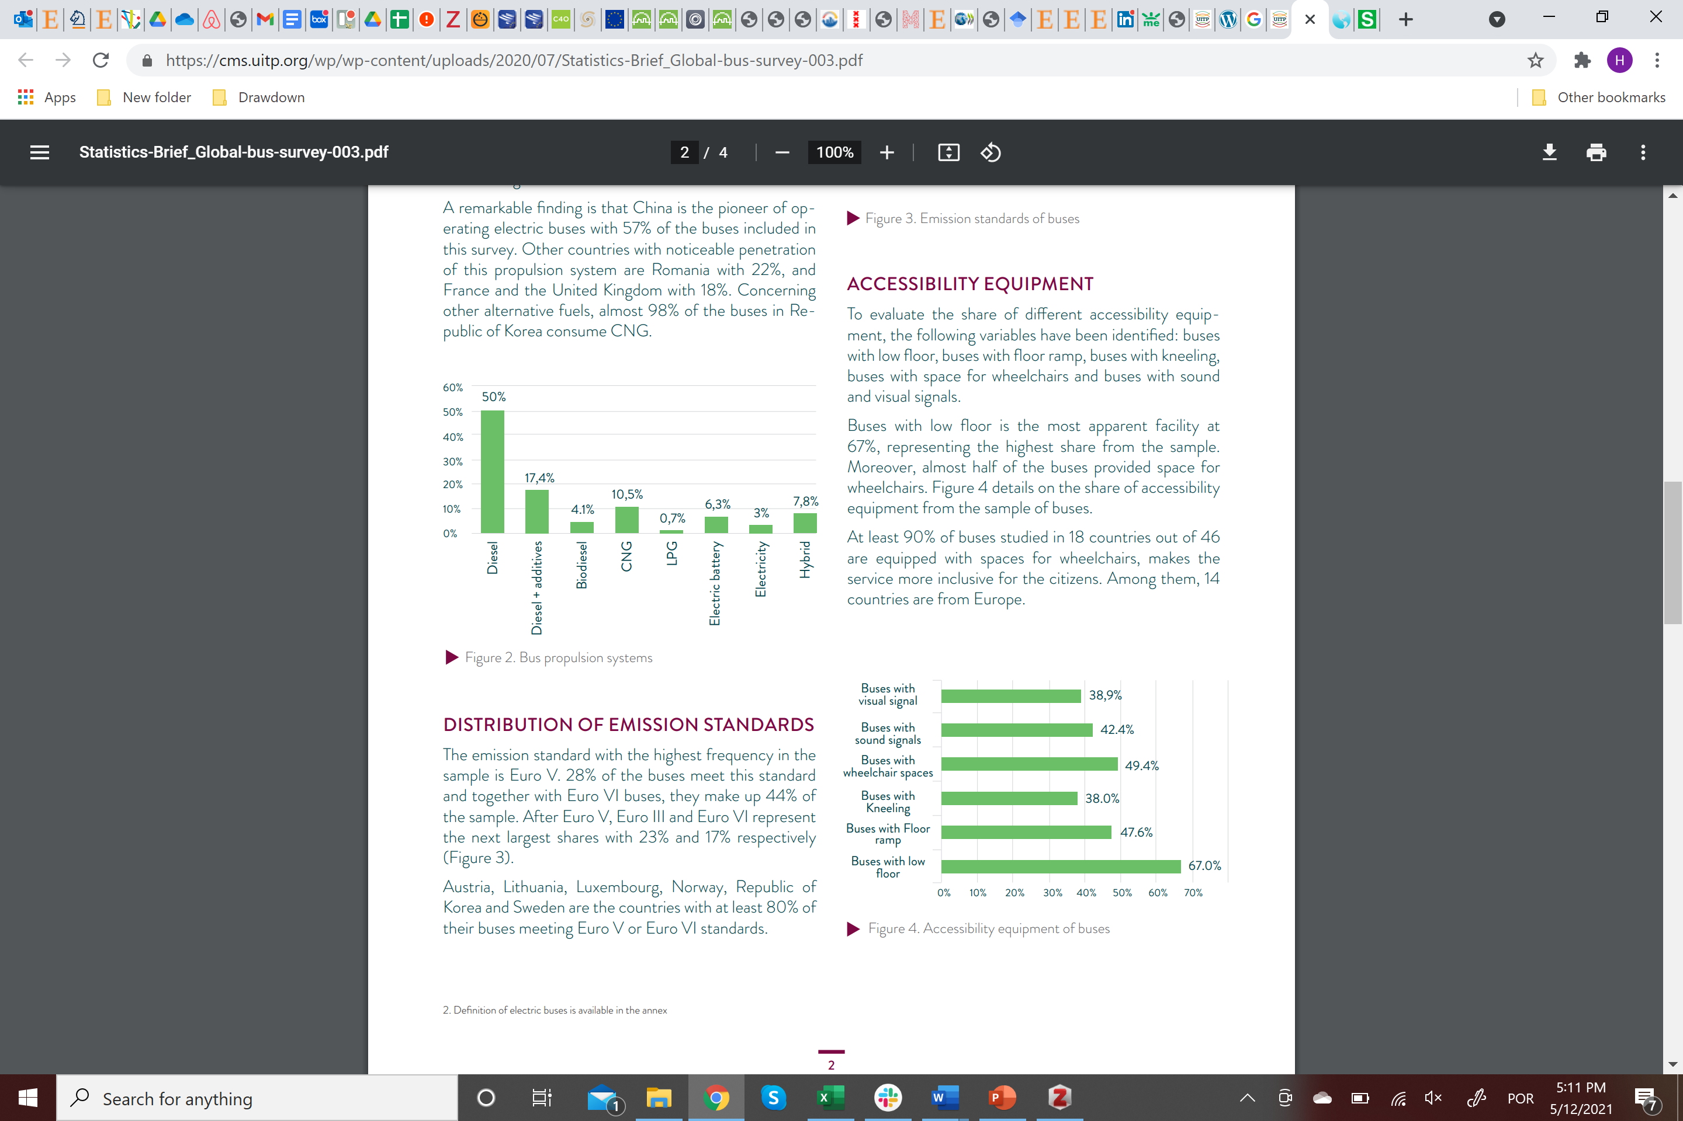

Figure ‎1.4:Type of energy consumed by global bus fleet (UITP, 2019a)

Bus Rapid Transit systems are median-aligned, segregated bus lanes with pre-board fare collection and platform-level boarding. As of March 2021, BRT had 5,331 kilometers in 177 cities with more than 34 million passengers per day (BRT Data, 2021).

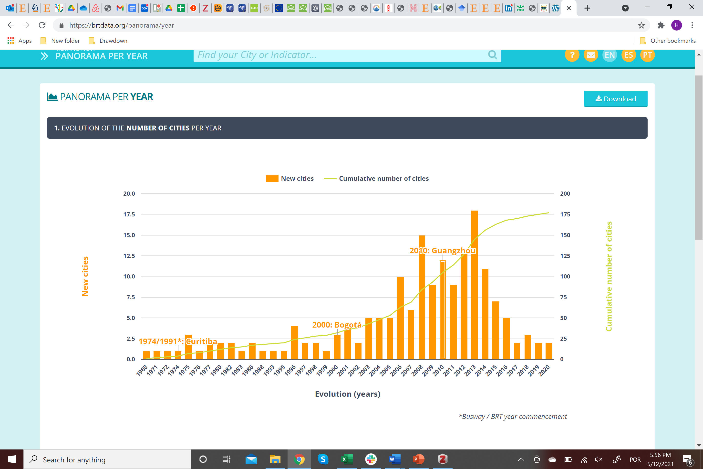

Figure ‎1.5: BRT Evolution (BRT Data, 2021)

#### Subway – Metro

Subways/metros are fixed route public transit systems. Metro systems have been deployed in cities of different sizes around the world. There is no unique definition for metro systems, but this report uses the definition provided by the International Association of Public Transport: “A metro is an urban guided transport system, mostly on rails, running on an exclusive right-of-way without any interference from other traffic or level crossings and mostly with some degree of drive automation and train protection. These design features allow high-capacity trains to run with short headways and high commercial speed. Metros are therefore suitable for the carriage of high passenger flows. (UITP, 2018)” Metros, therefore, are not necessarily underground. Moreover, metro trains are assumed to contain at least two cars and have a total capacity of at least 100 passengers. At the end of 2017, there were 182 metro systems with 642 lines totaling 11,084 metro stations and 13,903 kilometers of line infrastructure in the world. Average line length is approximately 20 kilometers, and average distance between stations on the world’s metros is approximately 1,250 meters. The commercial speed[2] of subways ranges from 20 to 40 km/h. From 2018 to 2022, 200 new lines are expected. In the middle of 2018, 5,400 kilometers were in construction or testing and 1,700 kilometers were in design and tender. Most of the growth has come Asia-Pacific and MENA (UITP, 2018).

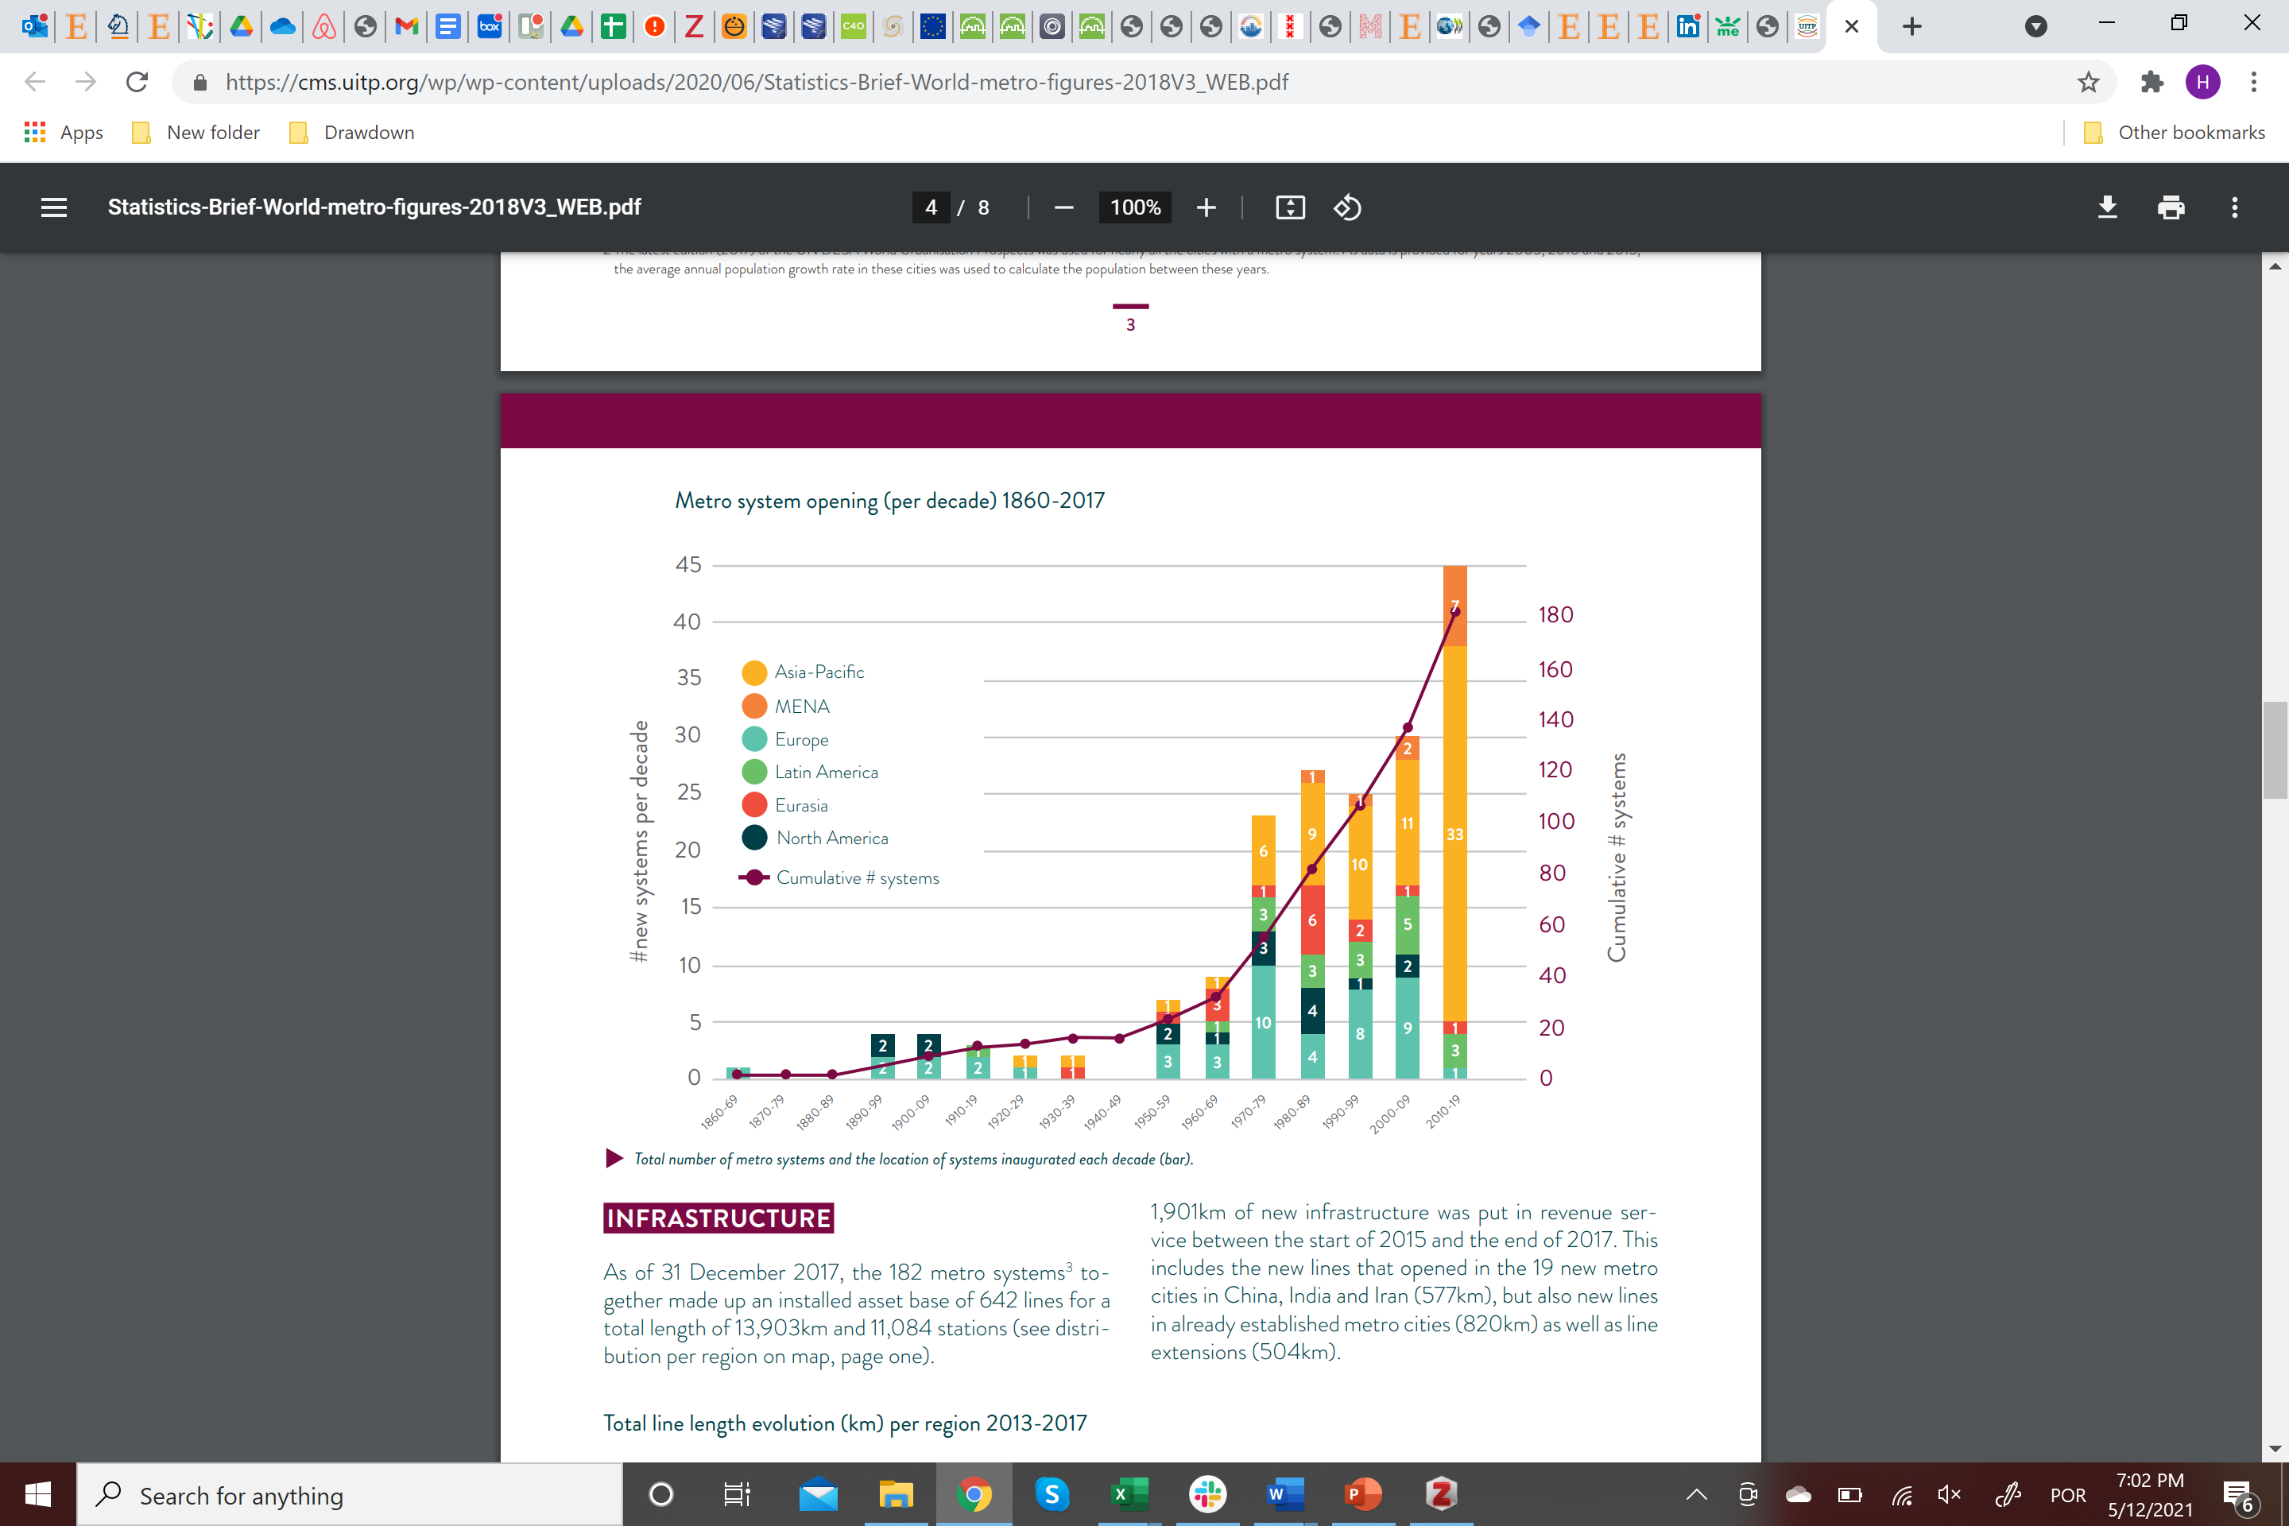

Figure ‎1.6: Metro system opening by decade (UITP, 2018)

#### Tram – Light Rail – Streetcar

Tram / light rail systems are also fixed route transport systems. Their definition according to UITP is as follows: “A public transport system, permanently guided at least by one rail, operated in urban, suburban, and regional environment with self-propelled vehicles and operated segregated or not segregated from general road and pedestrian traffic. (UITP, 2019b)”. Generally, they have less capacity than metro systems and are operated on surface. The average vehicle speed is also lower, at about 20 km/h. While tram / light rail has a very low mode share of public transit, it is experiencing a `renaissance`. Between 2000 and the end of 2018, 108 cities opened or reopened a line bringing the total to 389 cities globally. The recent developments and future growth will come mainly from Asia-Pacific (UITP, 2019b).

Other fixed route transit modes include monorail, suspended rail, and more. Their global use however, compared to metro and light rail is almost insignificant.

Almost all fixed route systems globally function with electricity provided by the electric grid.

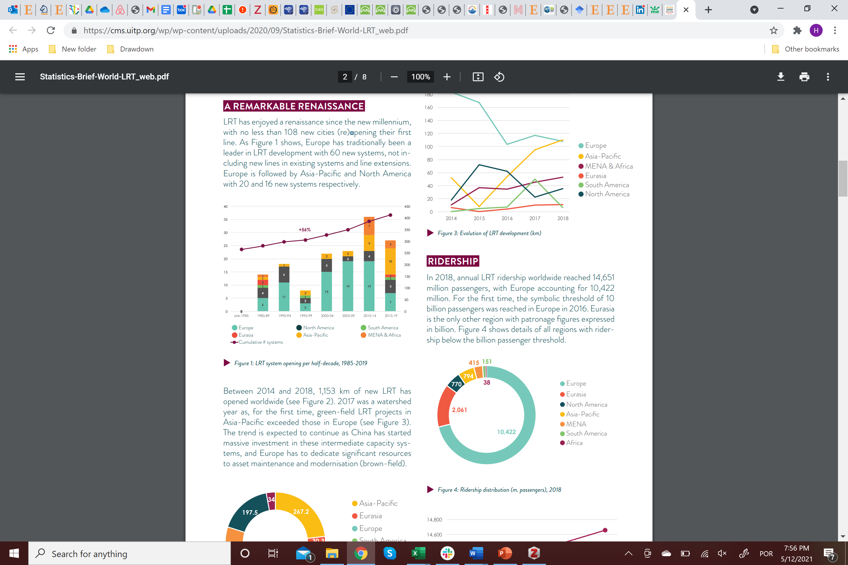

Figure ‎1.7: LRT system opening (UITP, 2019b)

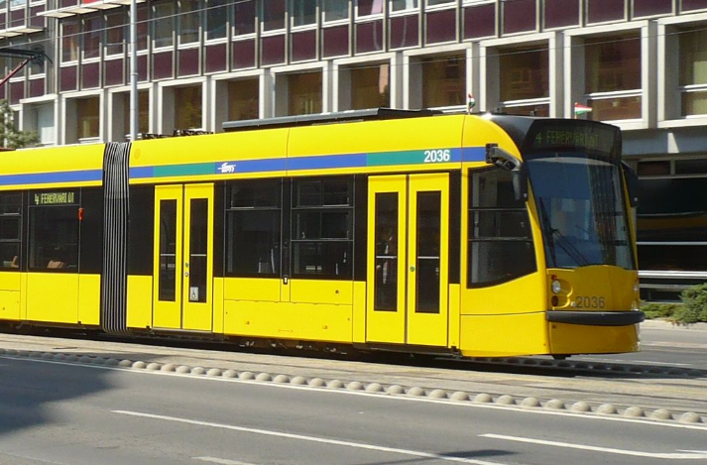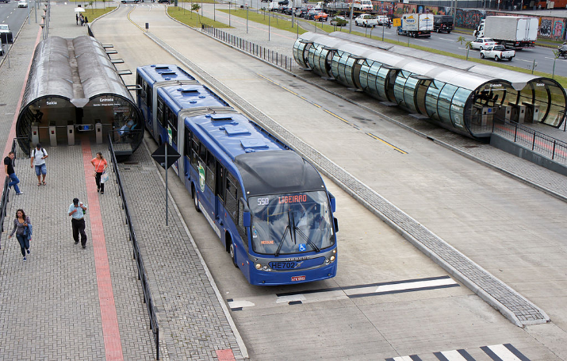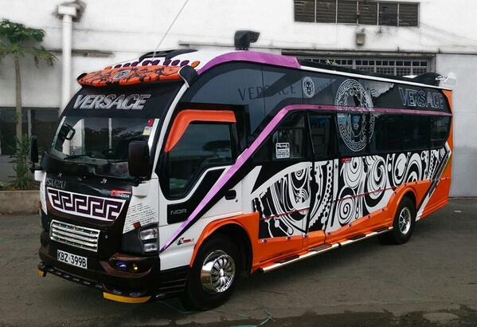

**A.**

**B.**

**C.**

**D.**

Figure ‎1.8 Example Public Transit Systems.

A: High-Capacity Metro train in Moscow (Russia). B: Modern Tram in Budapest (Hungary). C: BRT running on exclusive lanes in Curitiba (Brazil) showing Metro-like turnstiles, D: One of 20,000 Privately owned Minibuses called Matatus that form the Backbone of Nairobi’s (Kenya) Public Transit System. Source: www.Wikipedia.com

### Public Transit and Climate Change

Public transit is a climate solution (NASEM, 2021), as a result of the GHG savings that come from both transportation and land use efficiency. Transportation efficiency is the emissions reduced by passengers using public transit instead of personal vehicles. Other benefits include less energy use and improved air quality. The benefits to society that come from having public transit available are land use efficiencies such as shorter and fewer personal vehicle trips and more walking and bicycle trips.

## Adoption Path

### Current Adoption

The current modal share of public transit is the percentage of urban pkm done through public transit. Adoption projections are gathered from as many credible sources as possible. Sources include three highly renowned and respected institutions ITF, ITDP and IEA and are discussed below. The current adoption of public transit is estimated by calculating the average based on these sources. Current modal share can be seen in Table ‎1.1.

The International Transport Forum (ITF) reports mode share of urban passenger transport in its Outlook report that it publishes every other year. The ITF reports urban passenger mode share for rail, metro, light rail, bus, BRT, informal bus and taxibus which are summed to represent public transit. The ITF also provides mode share in three different scenarios. Public transit is expected to increase in all scenarios until around 2060 due to increases in wealth in low-income countries which leads to a decrease in informal bus and an increase in personal vehicles (ITF, 2021). The ITF Outlook 2021 is the only model and report that is available that takes the 2020 global pandemic into consideration.

The Institute for Transportation and Development Policy (ITDP), in cooperation with the University of California, Davis, produced a comprehensive global estimate of transportation mode shares and PKM through 2050. In ITDP’s estimate of a high-shift to sustainable transportation, the portion of urban PKM travelled by public transit increases steadily (UC Davis et al., 2015).

The share of urban pkm per mode is also estimated based on data from IEA ETP16. ETP16 has information both on urban and non-urban pkm, so one then is able to calculate the percentage of each. IEA, through ETP16 provides three different estimations on current modal share, so all of them are included in the calculations (IEA, 2016b).

Table ‎1.1 Current Global Modal Share and Adoption of Public Transit in billion pkm

|  | **Percent (%)** | **Billion PKM** |
| --- | --- | --- |
| Global Current Adoption | 29.9% | 9,673.0 |
| OECD 90 | 21.6% | 1,033.2 |
| Eastern Europe | 74.2% | 480.6 |
| Asia (Sans Japan) | 56.4% | 3,018.6 |
| Middle East and Africa | 86.0% | 1,338.7 |
| Latin America | 47.1% | 695.8 |

### Trends to Accelerate Adoption

#### New Modes

The new transport modes and alternatives, such as demand responsive buses and transport network companies (TNC) can help spur more adoption. These modes, by providing a comfortable and reliable alternative to private car, decrease the benefit of owning a private vehicle (Erhardt et al., 2021). The riders are then more likely to use public transit modes, especially if they work in cohesion with feeder and first/last mile services like mobility as a service partnership agreements in Boston, Chicago, Dallas, Denver, Sydney, Florida and Canada among many others (Lyft, 2021; Uber, 2021)

#### ICT

ICT apps from transit providers or companies like Citymapper or Google Maps are helping users to plan and time their trips on public transit which helps to increase ridership (Dimokas et al., 2018). The use of phones and contactless cards for payment also contributes toward adoption (Brakewood et al., 2020). Real time occupancy rates are helping to provide comfortability with public transit during the recent COVID-19 pandemic, and will likely be used for trip planning in the future (Wanek-Libman, 2020)

#### Climate Change Awareness

A trend that is likely to help the adoption of public transit is increased climate change awareness. Many efforts have been taken from countries and international organizations to push climate change higher in the agenda. Success can be claimed from the Paris COP 21 agreement, where 174 countries, including all major developed and developing countries, agreed to limit CO2 emissions in an attempt to limit temperature increase to 2 degrees Celsius compared to pre-industrial levels and reach zero net anthropogenic GHG in the second half of the 21st century.

### Barriers to Adoption

#### TNCs

TNCs or ride hailing (such as Uber, Lyft, DiDi, Grab, Pathao and Gokada) can complement or compete with public transit. When it competes, public transit rides are replaced instead of private car (Doppelt, 2018) by more than one-third (Acheampong et al., 2020; Rayle et al., 2016) and sometimes much higher (Clewlow & Mishra, 2017). However, in a few places such as Singapore it mostly replaces private car trips (Moody & Zhao, 2020) instead of public transit trips.

#### Urbanization

In some areas, mainly in Europe and megacities in the “developing” world, the modal share of public transit is significant. Yet, the trends in these two groups are opposite. European cities are facing a rise of the modal share of public transit through the last decade, something which is likely to continue in the future. Megacities in the “developing” world on the other hand, are pushed towards a path of higher car ownership and private car modal share, mainly due to increasing income levels and economic growth and the perceptions of a connection between car ownership and wealth. In these regions, policies and investments need to limit this trend and reinforce public transit usage. In other locations, investments in public transit are deemed necessary, so that the provided service can be a viable and attractive alternative to private car.

The increasing urbanization of the world is definitely going to affect this balance. The majority of growth will occur in cities without good public transit infrastructure and regulation. Without investments and strong policies that will boost public transit usage, the new travel demand will be facilitated by private vehicle modes, leading the modal share of public transit to steadily decrease. Even relatively optimistic prognostications predict a reduction in the share of public transit.

### Adoption Potential

Generally, research on modal shift/mode choice focuses on identifying the different elements that affect peoples’ choices; and try to determine how a change on those elements would affect the existing situation. Usually, the study area of these works is a city or a region. There are few research studies that try to predict modal share in the future, even less so on a global scale. International institutional bodies are the main source of information regarding the future direction of transport in general and mode choice specifically. A few of those efforts are presented below, highlighting the importance that is given towards public transit and the potential economic and environmental benefits generated by them.

#### International Transport Forum Transport Outlook 2021

The ITF publishes its Transport Outlook every two years. It is the only adoption study that had been performed since the start of the global pandemic at the time of the update to the model. It has three scenarios for future urban passenger transport to 2050. The scenarios get increasingly ambitious in regard to policies to decarbonize urban passenger travel which reduces emissions. The recover scenario represents a continuation of the priorities and policies that were in place before the pandemic began such as return to previous levels of public transit mode share, slowly electrifying personal vehicles and public transit fleets and a reversion of the shift to active modes. The reshape scenario represents a paradigm change such as deprioritizing cars, more efficient use of capacity and a transformation of public transit to a seamless Mobility as a service (Maas). The Reshape+ scenario reinforces the reshape scenario by locking in the positive trends that arose during the pandemic such as increased teleworking, increased active modes and converting the temporary infrastructure that was put in place for these modes to permanent. The reshape and reshape+ scenarios have total urban pkms declining and the modal share of public transit increasing.

#### Global PTx2 Vision

The International Association of Public Transport (UITP)—which has 1,300 members, including public transport authorities and operators from 92 countries—in 2009 established a vision and strategy called PTx2 for doubling public transit’s market share by 2025 and highlighted the areas where action is urgently needed. The PTx2 vision assumes that the market share[3] of public transit doubles over 20 years between 2005 and 2025 (from 16% in 2005 to 32% in 2025), but the share of walking and cycling remains stable (37%). Doubling public transit’s market share worldwide (PTx2) would save around 170m tons of oil and 550m tons of CO2 equivalent per year (UITP, 2009). While PTx2 vision seems to be ambitious, it is plausible since many cities around the world have already taken up the challenge and are working towards this goal. UITP supports this vision through a communication campaign, awards for sharing best practices and local sustainable mobility projects.

#### Energy Technology Perspectives

The International Energy Agency (IEA) regularly publishes Energy Technology Perspectives (ETP), a publication that focuses on the status of energy technologies and how they can contribute towards a more sustainable future. In the latest publication ETP20, the focus was on clean energy technologies and had a minor focus on only long-distance transport, not urban (IEA, 2020). ETP16 was the latest version that had comprehensive data and scenarios that are relative to urban transport and was therefore used. ETP16 (IEA, 2016a) it provides a perspective on the possibility of emissions reduction using three different scenarios. The three scenarios are categorized by the change in ambient air temperature between the pre-industrial era average and 2050 (6DS, 4DS, and 2DS). 6DS stands for 6 degree Celsius change and can be considered as a business-as-usual scenario, without any significant changes on current practices. 4DS can be achieved through fulfilling targets that have been set recently (Paris COP 21[4], agreement on GHG reduction, etc.). 2DS being the most ambitious scenario would reduce primary energy demand by 30% (compared with 6DS) and CO2 emissions by 70% (50% compared with current levels). The transport chapter of ETP has a summary of different transportation related changes and technologies that could help reduce CO2 emissions. Among them, modal shift offers great potential, especially in limiting emissions from developing countries. To achieve this goal, increased investments in public transit systems (existing or new), can help the cities ensure cheap and efficient mobility for their citizens.

#### A Global High Shift Scenario 2050

The report “A Global High Shift Scenario: Impacts and Potential for More Public Transport, Walking, And Cycling with Lower Car Use”—published in September 2014 by the Institute for Transportation and Development Policy (ITDP) and University of California, Davis—examines how major changes in urban transport investments worldwide would affect urban passenger transit. The report calculates CO2 emissions in 2050 under two scenarios: a) business-as-usual; and b) High Shift. In High shift governments and other governing bodies “increase rail and clean bus transport, especially bus rapid transit (BRT), and help urban areas provide infrastructure to ensure safe walking, bicycling and other active forms of transportation”. In the projections, investments on car-oriented infrastructure such as road construction and parking garages are decreased, in order to discourage car ownership. The study uses the United Nations urban population forecasts and extends the global Mobility Model (MoMo) framework developed by the International Energy Agency (IEA) to investigate the extent of various urban passenger transport systems in cities across the world, as well as new estimates of the extent of mobility by non-motorized transport and low power e-bikes.

According to the study by ITDP and UC Davis, “more than USD$100 trillion in cumulative public and private spending could be saved, and 1,700 megatons of annual carbon dioxide (CO2)—a 40 percent reduction of urban passenger transport emissions—could be eliminated by 2050 if the world expands public transportation, walking and cycling in cities”.

The report by ITDP & UC Davis concludes the following: “Given the assumptions made and scenarios compared, the main finding is that a high transit, high-non-motorized-vehicle scenario that (at least in the developing world) provides similar total mobility (in passenger kilometers) as a baseline, more car-dominated scenario, is likely to be more equitable, less expensive to construct and operate over the next 40 years, and to sharply reduce CO2 emissions. Unmanaged growth in motor vehicle use threatens to exacerbate growing income inequality and environmental ills, while more sustainable transport delivers access for all, reducing these ills. This report’s findings should help support wider agreement on climate policy, where costs and equity of the cleanup burden between rich and poor countries are key issues.”

#### Global Transportation and Energy Roadmap

The International Council on Clean Transportation (ICCT) published in 2012 the Global Transportation and Energy Roadmap (ICCT, 2015). The report examines the global effect of transportation policies on oil consumption and emissions and evaluates the potential for their reduction. This is achieved by transferring best practices around the globe and by efficiently integrating new technological developments. Moreover, it is believed that policies with stricter focus on sustainable development and emission reduction must be taken if keeping global temperature average below 2 degrees is to be achieved. Modal shift is a key part of this report, demonstrating the beneficial effects it has towards the set goals. However, it is acknowledged that the complexity associated with modal changes is much greater compared with other sections of the report. Lower regulatory certainty, policy package complexity, and fewer examples of best practices are among the reasons for this. Yet, since growth in vehicle activity plays the most significant role in increasing global emissions, modal shift and activity reduction policies can play a key role in reducing oil consumption and CO2 emissions. Their estimation is that these two elements can lead to reductions up to 6.6 Mboe[5]/day and 1.3 GtCO2e[6] by 2030.

#### EU Transport 2050

Urban transport is responsible for about a quarter of CO2 emissions from transport in Europe. The European Commission in 2011 adopted a comprehensive strategy called Transport 2050 for a competitive transport system aimed to “increase mobility, remove major barriers in key areas and fuel growth and employment” and to “dramatically reduce Europe's dependence on imported oil and cut carbon emissions in transport by 60% by 2050”.

The strategic document “Roadmap to a single European transport area” presents the European Commissions’ vision for the future of the EU transport system and defines a policy agenda for the decade 2010-2020 (European Commission et al., 2011). It defines a set of goals designed to guide policy actions and measure progress and includes phasing out conventionally fueled cars from cities by 2050.

To achieve clean urban transport and commuting the Transport 2050 strategy: “plans for cities to switch to cleaner transport facilitated by the lower requirements for vehicle range and higher population density. Public transport choices are planned to be more widely available, as well as the option of walking and cycling”.

## ADVANTAGES AND disadvantages of Public Transit

### Similar Solutions

Solutions that are similar to or can replace public transit are all other modes that serve the urban passenger market. These modes include car, e-bike, conventional bike, walking, e-kick scooters and e-mopeds. All but the last two modes (which are considered motorized 2/3 wheelers) are current Drawdown Solutions (car encompasses three solutions-electric, hybrid and sharing which will be evaluated as a unit).

### Arguments for Adoption

Public transit is a good mode choice for urban passenger transit. It is an important component of the mix of mode choices and has the ability to shift use from modes with higher emissions. It enables some use from riders that would not use the conventional option. The solution`s advantages and disadvantages are better understood when compared to the other available urban passenger mode choices. 2/3 wheelers are not currently Drawdown solutions and will not be evaluated as to whether the benefits outweigh the costs because there is no consensus and Drawdown has not yet modeled the results.

Public transit costs in this analysis are the costs to the user, not the builder or operator. Therefore, at the user level, it is one of the most cost-effective modes. Only walking costs less and e-bikes and traditional bikes are similar when comparing bike sharing rather than ownership (although ownership when amortized by pkm over the life of the bike is also similar). Cars are significantly more costly due to the purchase, depreciation, maintenance and operation (fuel and insurance) costs. However, there are significant costs to the municipalities/operators of public transit that must supply the vehicles and the infrastructure and often subsidize the user costs as well. This results in indirect costs to individuals through taxation and opportunity costs for other tax-based services. Cars also have significant costs to governments/operators that build and maintain the infrastructure. This results in costs to users through fuel taxes, other taxes and opportunity costs.

The solution per pkm, emits significantly less than cars. By pkm, metro is one of the least polluting modes, and many buses are now electric, which further reduces emissions. However, indirect emissions come from manufacturing the different vehicles used by each mode. Public transit requires a much higher level of materials than walking and traditional bike infrastructure.

The solution is much faster than a conventional bike and walking. In congestion, which is common in the urban passenger market that is modeled, public transit can go as fast or faster than cars (Altieri et al., 2020) especially if there is dedicated infrastructure. E-bikes are selected over public transit when it is perceived as faster, or congestion is a factor.

Public transit requires less physical effort than walking or conventional bike. The physical efforts include boarding and possibly traversing a station. The solution requires approximately as much physicality as private vehicles and slightly less than e-bikes.

This solution does not contribute nearly as much to congestion (AlKheder, 2021) as do cars, including TNCs (Diao et al., 2021).

The space efficiency of e-bikes, conventional bikes and walking are significantly less than that of public transit. Comparing the solution to private vehicles is complex as a bus can take up the same space as a car but dedicated lanes for buses or trams take up less space as cars usually have multiple lanes.

### Additional Benefits and Burdens

Additional benefits include increased road safety for all road users including public transit riders, pedestrians and cyclists (Morency et al., 2018; UITP and ICLEI, 2020). Cities with high public transport use have low traffic fatalities which has another benefit of helping to achieve SDGs 3 and 11 (UITP and ICLEI, 2020).

Public transit facilitates accessibility across cities connecting users with jobs and businesses which translates into increased employment and sales leading to growth in the economy (UITP, 2021, p. 2021).

Any rebound effects of induced trips are not a burden as a marginal rider increases vehicle occupancy and decreases the emissions per pkm.

Burdens are the opportunity costs of financial expenses to municipalities that could be used for other public services.

Table ‎1.2 Urban Passenger Mode Comparison

|  | **User Costs** | **Emissions** | **Speed** | **Physicality** | **Congestion** | **Space Efficiency** |
| --- | --- | --- | --- | --- | --- | --- |
| E-Bike | Low | Low | High | Medium | Low | Low |
| Conventional Bike | Low | None | Medium | High | Low | Low |
| Car | High | High | Medium | Low | High | High |
| Public Transit | Low | Low | High | Low | Low | Medium |
| Walking. | Low | None | Low | High | Low | Low |

# Methodology

## introduction

Project Drawdown’s models are developed in Microsoft Excel using standard templates that allow easier integration since integration is critical to the bottom-up approach used. The template used for this solution was the Reduction and Replacement Solutions (RRS) which accounts for reductions in energy consumption and emissions generation for a solution relative to a conventional technology. These technologies are assumed to compete in markets to supply the final functional demand, which is exogenous to the model, but may be shared across several solution models. The adoption and markets are therefore defined in terms of functional units, and for investment costing, adoptions are also converted to implementation units. The adoptions of both conventional and solution were projected for each of several scenarios from 2015 to 2060 (from a base year of 2014) and the comparison of these scenarios (for the 2020-2050 segment[7]) is what constituted the results.

The functional unit[8] of the analysis is the passenger kilometer (pkm); and the implementation unit[9] the urban trip. The agency level used for the analysis is the individual, as the agent that will decide whether to use car or mass transit is the individual that makes the trip. Therefore we analyze these impacts on the perspective of the individual user rather than from the municipality or operator of the infrastructure.

The Total Addressable Market (TAM) covers all demand for the function provided by the solution. For public transit, the TAM is global demand for urban passenger travel including conventional and emerging solutions. Most reports available in the literature exclude non-motorized trips when calculating urban modal share. This was repeated here for two main reasons. First the modal share is calculated through pkm, and therefore the smaller trip distance of a non-motorized trip results to a much smaller share. Second, non-motorized trips are much harder to record and predict. Adjustments have been made to account for the non-motorized pkm. One should note however than non-motorized trips are often complementary to public-transit trips, and so an increase in public transit adoption should lead to increased walking, cycle infrastructure patronage and electric bicycle usage, three other solutions examined in Project Drawdown.

The Project Drawdown Scenarios, (PDS), estimate an annual increase of the modal share of public transit in urban environments as the total number of pkm grows. The increased number of public transit trips will mainly come from newly generated trips, although some will come from existing private vehicle, non-motorized, or other mode trips.

The conventional technology in this model will be the private car, more specifically ICE cars. Since hybrid, electric, or other engine vehicles sum up to only a few percent of the global car fleet, they will not be considered in this approach.

The solution on the other hand is public transit. Since public transit consists of multiple modes, only the more dominant modes are considered: namely bus, BRT, minibus, subway, and light rail. Impacts regarding climate and financial impacts of public transit will be calculated by aggregating the individual mode outputs weighted by vehicle fleet.

As mentioned previously, the functional unit of the analysis is the passenger kilometer and the implementation unit the urban trip. Since the conventional technology and solution have different average trip lengths, estimations will be done using these figures. Average urban trip length for a private car is 9km (ITDP), which corresponds to 15.36 pkm (average car occupancy rate sources listed below). Average urban trip length for public transit is 7.02 km. It is estimated from equation 1 using ITDP data for individual transit modes.

$${trl}_{T}=\sum_{1}^{m}{{trl}_{m}*{fl}_{m}}$$

Where

*trlm* is the average trip length for mode m;

*trlT* is the average trip length for public transit;

*flm* is the fleet size for each mode m.

## Data Sources

Data from multiple sources were compiled to construct this model, with an emphasis on recent, credible, and peer-reviewed methodology. The data sources used for the model have been divided in three main sections: Total Addressable Market (TAM), Adoption Projections and Variable Inputs.

### Total Addressable Market

The Total Addressable Market (TAM) covers all demand for the function provided by the solution. For the Public Transit solution, TAM is world urban passenger kilometers made by all modes. Global TAM was projected mainly using data obtained from (IEA, 2016a; The International Council on Clean Transportation, 2012; UC Davis et al., 2015). Regional data come from ITDP-UC Davis (UC Davis et al., 2015).

### Adoption Projections

Adoption projections are gathered from as many credible sources as possible. Sources include (IEA, 2016a; OECD/ITF, 2021; UC Davis et al., 2015). Regional data come from ITF and ITDP-UC Davis (OECD/ITF, 2021; UC Davis et al., 2015)

### Variable Inputs

Variable inputs are used in the Variable Meta-Analysis and are updated to reflect current conditions at each update.

#### Financial Variables

Financial variables include first costs and operating costs for both conventional and the solution. Operating costs are variable and fixed and are derived from lifetime capacity and average annual use for conventional and solution.

Conventional first costs are mostly reported at the regional level and are based on (IEA, 2019; IEA & ICCT, 2019; ITDP, 2019; Lutney & Nicholas, 2019; Mock, 2018) (Carnext, 2019; Carview, 2019; Coren, 2019; Feijter, 2018a, 2018b; Gasnier, 2019; Hu, 2019a, 2019b; IEA, 2019; IEA & ICCT, 2019; ITDP, 2019; Lutney & Nicholas, 2019; Mock, 2018; Ning, 2018; Tate, 2019; Wang, 2017, 2018).

There is no solution first cost data because the analysis is from a user perspective and the user is not charged for the purchase of the transit vehicle.

The conventional and solution lifetime capacity data and average annual use come from (UC Davis et al., 2015).

Conventional variable operating costs are regional and based on (AAA, 2019; Bartlett, n.d.; BTS, 2019; Masson, 2018).

Solution variable operating costs are regional and come from (Dillinger, 2017; Litman, 2021).

Conventional fixed costs are based on (AAA, 2019; Hagman et al., 2016; Masson, 2018; Norman, 2021).

There are no solution fixed costs.

#### Emissions Reduction Variables

Solution total energy used is based on (UC Davis et al., 2015).

The conventional fuel consumed per pkm data is from (Bieker, 2020; ITF/OECD, 2020; Schäfer & Yeh, 2020; Wu et al., 2019) some of which have multiple data points for many countries.

Solution fuel efficiency factor is based on (UC Davis et al., 2015).

Indirect emissions for conventional and solution data come from (ITF/OECD, 2020).

#### Additional Variables

Average car occupancy comes from a variety of sources including (Center for Sustainable Systems University of Michigan, 2020; Environmental and Economic Policy Research Center of the Ministry of Ecology and Environment, 2018; ITF/OECD, 2020; Liu et al., 2017; McQueen et al., 2020; Schäfer & Yeh, 2020).

Average car lifetime data come from several sources such as (Hawkins et al., 2012; ITF/OECD, 2020; NHTSA, 2006; Zheng et al., 2019).

The household discount rate is based on data from (Koster & Pinchbeck, 2018; Li & Pizer, 2018, 2021; Martin et al., 2020).

## Total Addressable Market

The total addressable market is the total of functional transportation units provided to the world urban market by all modes. Data were obtained from the International Council on Clean Transportation (ICCT), Institute for Transportation and Development Policy (ITDP) and International Energy Agency (IEA). The values shown represent the average from all the sources (Table 2.1). Since most of the collected data report values in 5-year intervals, values for the in-between years were estimated with the use of data interpolation. Regional data come from the ITDP-UC Davis study, taken from their High Shift scenario. While the global TAM more than doubles throughout the study period, that the regional TAMs for OECD90 and Eastern Europe initially grow before returning to around 2015 levels. The growth comes mainly from Middle East and Africa region, where the TAM is almost 4 times bigger; and Asia, where the TAM more than doubles by 2050. In Latin America the TAM grows about 80%.

Table ‎2.1 Global and Regional TAM, in billion pkm

|  |  |  |  |  |
| --- | --- | --- | --- | --- |
| **Drawdown Region** | **2015** | **2030** | **2045** | **2050** |
| World | 26,539 | 38,473 | 51,468 | 56,606 |
| OECD90[10] | 9,476 | 9,741 | 9,323 | 9,281 |
| Eastern Europe | 1,261 | 1,317 | 1,277 | 1,273 |
| Asia (sans Japan) | 9,459 | 15,411 | 20,582 | 22,091 |
| Middle East and Africa | 2,847 | 4,614 | 7,963 | 9,485 |
| Latin America | 2,715 | 3,863 | 4,721 | 4,943 |

## Adoption Scenarios

Two different types of adoption scenarios were developed: a Reference (REF) Case which was considered the baseline, where not much changes in the world, and a set of Project Drawdown Scenarios (PDS) with varying levels of ambitious adoption of the solution. Published results show the comparison of one PDS to the REF, and therefore focus on the change to the world relative to a baseline.

### Reference Case / Current Adoption

For most Project Drawdown solutions, the REF scenario assumes that the 2014 adoption of the solution is “frozen” for the study period. However, in the case of public transit, based on the reports mentioned on the literature, a “frozen” REF is quite optimistic. Expectations for the future include a sharp decrease in public transit modal share, especially in the developing world, mainly in Asia and Africa, with the current modal shares in Europe and North America remaining stable. Therefore, in the REF scenario, the passenger kilometers for public transit will “freeze”, staying at the levels of 2014 throughout 2050. As the TAM grows, the share of public transit will decrease. This is consistent with what most reports and predictions for the future claim, assuming a REF approach.

### Project Drawdown Scenarios

Three Project Drawdown scenarios (PDS) were developed for each solution, to compare the impact of an increased adoption of the solution to a reference case scenario. Three sources were used to make the PDS projections, the International Transport Forum (OECD/ITF, 2021), International Energy Agency (IEA, 2016a) and Institute for Transportation and Development Policy (ITDP), in cooperation with the University of California, Davis (UC Davis et al., 2015). The ITF reports public transit PKMs globally and regionally to 2050. IEA estimates mode share of public transit which is then calculated into public transit pkms based upon the total urban passenger pkms from the same source (IEA). ITDP reports a global estimate of transportation mode shares and PKM through 2050. Estimates of public transit share were made based on the proportion of public transit pkms based on a meta-analysis of all modes made for integration of all solutions by Drawdown.

In the PDS scenario, stakeholders and policy makers around the world take the appropriate decisions that will encourage public transit adoption throughout the world. That can mean different things in different regions. Everywhere however, strong investment in transit infrastructure will be necessary, albeit at different levels. In Europe for example, where most transit systems are in good condition, investments should be focused in improving the provided service, and help boost the existing upward trend of public transit modal share. In North America, the development of new public transit systems should be a priority, especially in cities that today are more car oriented. Creating new, modern, and reliable systems, together with policy decisions that encourage transit usage and provide incentives to decrease car use, can lead to an increase of public transit modal share. Similarly, in Asian megacities and other regions with high transit use (mainly in Central and South America), strong investments are needed to ensure that public transit systems remain peoples’ choice in the future. In most of these megacities, strong policies in favor of public transit already exist; but keeping and reinforcing them must be the policymakers’ target, to prevent a modal shift in favor of private car. In other regions around the world, where the largest part of the new travel demand will come from, substantial investments and efforts on all fronts are required. Substantial urban development will be needed in these regions, so there lies a big opportunity. These new urban areas can be developed after “transit-successful” cities, in Europe or Asia, with emphasis on transit systems and mixed land use. Combined with strong transit and non-motorized transport friendly policies, transit could absorb a significant part of the new trips. Beyond that, campaigns that target the behavioral and attitudinal aspect of people must be also undertaken.

These recommendations can be found in most reports dealing with sustainable urban transport for the future. Based on information that is collected from different sources in the literature, maintaining a steady modal share of public transit seems an optimistic and plausible scenario that fits the goal. In the model, to ensure that everything is taken into account, some existing prognostications in the adoption data that correspond to more pessimistic scenarios are included. For these two reasons, the estimated adoption growth is set to “high”, meaning one standard deviation above the mean of the existing adoption prognostications.

#### Plausible Scenario

This scenario assumes the conservative TAM predictions based on ETP (IEA, 2016a) URBAN 4 DS + Non-motorized Travel Adjustment and ITDP/UC Davis (UC Davis et al., 2015) 'A Global High Shift Scenario' Updated Report Data - Baseline Scenario and the conservative adoption predictions based on IEA ETP 16 4DS (IEA, 2016a) and ITF Reshape (OECD/ITF, 2021)

#### Drawdown Scenario

This scenario assumes the ambitious TAM predictions based on ETP (IEA, 2016a) URBAN 2 DS + Non-motorized Travel Adjustment and ITDP/UC Davis (UC Davis et al., 2015) 'A Global High Shift Scenario' Updated Report Data – High Shift Scenario and the ambitious adoption predictions based on ETP 16 2DS with recent historical data added (IEA, 2016a) and ITDP/UC Davis (UC Davis et al., 2015)'A Global High Shift Scenario' Updated Report Data – High Shift with recent historical data added and ITF Reshape+ (OECD/ITF, 2021).

#### Maximum Scenario

This scenario assumes the baseline TAM predictions based on ETP (IEA, 2016a) URBAN 6 DS + Non-motorized Travel Adjustment and ICCT (The International Council on Clean Transportation, 2012) "Global Transportation Roadmap Model" + Non-motorized Travel Adjustment and adoption is based on the maximum expected mass transit mobility worldwide as 45% of the Urban mobility TAM in 2050, we project a linear growth out to 2050 from current adoption in 2018.

## Inputs

Many variables have been defined and calculated for this analysis. They are grouped by climate inputs, financial inputs and technical inputs. Each variable is described below. In the analysis, the agent that will decide whether to use car or public transit is the individual that makes the trip. Therefore, the impacts on the perspective of the user are analyzed.

### Climate Inputs

This section addresses the environmental inputs of the model. These can be either direct emissions, through fuel combustion or the electricity grid, or indirect, through the construction of the vehicles.

#### Direct Emissions

Direct emissions can come from fuel combustion or from electricity consumption. Certain assumptions regarding the technologies are made to calculate them. All conventional technology vehicles are ICE cars, therefore conventional has only fuel-combustion related emissions. On the other hand, public transit is a plethora of modes, some of which use ICE, while others use grid electricity. Therefore, the solution has both types of direct emissions.

For ICE cars, the input required is the average liters of fuel required per pkm. This information has also been used for the calculation of the operational cost of cars. It is calculated by dividing the average fuel consumption fec by the average car occupancy AOc.

To calculate the reduction obtained by the solution technology, one estimates how much fuel would be saved by switching a car pkm to a public transit pkm. For the average fuel consumption of a public transit pkm however, one needs to consider all transit modes that use ICE, in specific buses, minibuses, and BRT.

Rail public transit modes, namely subway, light rail, and commuter rail, use grid electricity to function. Furthermore, a growing percent of buses and minibuses are electric or hybrid. Therefore, the amount of energy consumed per trip is estimated, to estimate the respective emissions for electricity production. Calculations from the Drawdown team have been used for all these figures.

#### Indirect Emissions

Indirect emissions from vehicle manufacturing must also be taken into account. Figures from various sources, related with the CO2e emissions generated to produce an ICE car or a public transit vehicle (bus and rail), are used to calculate these emissions per pkm.

Table ‎2.2 Climate Inputs

|  | **Units** | **Project Drawdown Data Set Range** | **Model Input** | **Data Points (#)** | **Sources (#)** |
| --- | --- | --- | --- | --- | --- |
| Total Energy Used per Functional Unit - SOLUTION | *Twh per PKM* |  | 9.28E-12 | 1 | 1 |
| Fuel Consumed per Functional Unit - CONVENTIONAL | *Liter/ PKM* | 0.07-0.10 | 0.08 | 8 | 4 |
| Indirect CO2 Emissions per CONVENTIONAL Functional Unit | *t CO2-eq/ PKM* | 5.59E-05-7.36E-05 | 6.51E-05 | 4 | 1 |
| Indirect CO2 Emissions per SOLUTION Unit | *t CO2-eq/ PKM* | 5.24E-06-9.82E-06 | 7.53E-06 | 2 | 1 |

Note: Project Drawdown data set range is defined by the low and high boundaries which are respectively 1 standard deviation below and above the mean of the collected data points[11].

### Financial Inputs

This section addresses the financial inputs of the model, by splitting them to first and operational cost. The costs have been converted to US$2014 based on inflation.

#### First Cost

Since this analysis is from a user perspective, first cost exists for the conventional technology (private car), but not for public transit (solution). The user is responsible for purchasing their car, whereas the person is not directly charged for the purchase of the transit vehicle (bus, rail). The first cost for the private car is estimated per implementation unit, the urban trip. The formula to estimate it is the following:

$${FCt}_{c}=\frac{{FC}_{c}}{n_{tr}}$$

Where

FCtc is the first cost per trip for car;

FCc is the first cost of buying a car;

Ntr is the number of trips a car does in its lifetime (estimated by dividing the average lifetime vkm[12] of a car; to the average urban car trip length).

#### Operational Cost Factors

Conventional and solution operating and maintenance costs are on a $2014/pkm basis and are regionalized and weighted by mode share. The bottom-up approach is used due to the differences in mode share and costs across the regions.

The conventional, ICE cars, carry the additional fixed expense of insurance to the user and is calculated to a pkm basis and added to the operating costs.

For the conventional technology, the variable operating cost is calculated by combining maintenance and fuel costs and estimating the total cost per pkm. To do this steady oil prices were assumed for the duration of the study[13]. The calculation is the following:

$${VOC}_{c}= \frac{{MC}_{c}+(f*{fe}_{c})}{{AO}_{c}}$$

Where

VOCc is the variable operational cost of private car per pkm;

MCc is the maintenance cost of private car per vkm;

f is the fuel price per liter;

fec is the fuel consumption in liter per vkm for private car;

AOc is the average car occupancy (in pkm per vkm).

There are no fixed operating costs for the solution.

For the solution, the variable operating cost is the public transit ticket price, estimated by weighting ticket price with the transportation volume in each region. The calculation is the following:

$${OC}_{T}= {\sum_{m=1}^{n}{{OC}_{Tm}*w_{m}}}/{{trl}_{T}}$$

Where

OCT is the operational cost of transit (global average ticket price) per pkm;

OCTm is the average ticket price for region m;

wm is the weight of each region m, calculated as the percent of transport volume done in that region vs. the total;

trlT is the average trip length of a transit trip.

All operational costs are estimated per pkm, the functional unit, to provide comparable results.

#### Learning Rate Factor

Due to the maturity of the technologies, the conventional and solution efficiency rate is very close to zero.

#### 2.5.2.4 Discount Rate

The household discount rate of 3.2% was used based on the average of 3 peer reviewed sources reporting global household discounting.

Table ‎2.3 Financial Inputs for Conventional Technologies

|  | **Units** | **Project Drawdown Data Set Range** | **Model Input** | **Data Points (#)** | **Sources (#)** |
| --- | --- | --- | --- | --- | --- |
| First costs (Conventional) | *US$2014/Person trip* | 0.86-1.23 | 1.05 | 19 | 17 |
| Fixed Operation and Maintenance Costs (Conventional) | *US$2014/Person trip* | 0.174-0.617 | 0.396 | 20 | 6 |
| Variable Operation and Maintenance Costs (Conventional) | *US$2014/Pkm* | 0.00-0.447 | 0.218 | 5 | 4 |
| Fuel Price (Conventional) | *US$2014/liter* |  | 1.04 |  |  |

Table ‎2.4 Financial Inputs for Solution

|  | **Units** | **Project Drawdown Data Set Range** | **Model Input** | **Data Points (#)** | **Sources (#)** |
| --- | --- | --- | --- | --- | --- |
| Variable Operation and Maintenance Costs (Solution) | *US$2014/Pkm* | 0.048-0.242 | 0.145 | 6 | 2 |

### Technical Inputs

Besides only climate- and financial-oriented variables, some variables have been defined which apply to both climate and financial results. These are called Technical inputs and are described below.

#### Replacement Factors

The Conventional and Solution Implementation unit is only relevant for a defined number of pkms equal to one trip. The conventional and solution average annual use and the lifetime capacity are therefore the same and is one trip.

#### Technical Factors

Other variables were used in the calculations for the climate, financial and replacement factors. They are listed below.

Table ‎2.5 Technical Inputs

|  | **Units** | **Project Drawdown Data Set Range** | **Model Input** | **Data Points (#)** | **Sources (#)** |
| --- | --- | --- | --- | --- | --- |
| Average Car Occupancy | Persons/vehicle | 1.39-2.04 | 1.72 | 15 | 6 |
| Average Car Lifetime | VKM | 153,815-289,919 | 221,867 | 16 | 4 |
| Discount Rates - Households | Percent | 3.0%-3.4% | 3.2% | 4 | 3 |

## Assumptions

Six overarching assumptions have been made for Project Drawdown models to enable the development and integration of individual model solutions. These are that infrastructure required for solution is available and in-place, policies required are already in-place, no carbon price is modeled, all costs accrue at the level of agency modeled, improvements in technology are not modeled, and that first costs may change according to learning. Full details of core assumptions and methodology will be available at [www.drawdown.org](http://www.drawdown.org). Beyond these core assumptions, there are other important assumptions made for the modeling of this specific solution. These are detailed below.

1. All cars identified as a “convectional technology” use ICE;
2. Travel mode fuel efficiencies and fuel prices remain constant through 2050;
3. Average urban trip lengths with cars and public transit remain constant through 2050;
4. Mode Energy Usage: Urban bus and Mini bus use liquid fuel and electricity; Cars and BRT use only liquid fuel; Metro, Tram, and Commuter rail use only electricity.

## Integration

The complete Project Drawdown integration documentation (will be available at [www.drawdown.org](http://www.drawdown.org)) details how all solution models in each sector are integrated, and how sectors are integrated to form a complete system. Those general notes are excluded from this document but should be referenced for a complete understanding of the integration process. Only key elements of the integration process that are needed to understand how this solution fits into the entire system are described here.

Each solution in the Transportation sector (including Walkable Cities and Bike Infrastructure) was modeled independently and integration was performed to ensure consistency within the sector. Intra-sectoral integration of the transportation solutions was based on two main components:

* TAM/Adoption Consistency: Ensuring that all solutions that are in the same “market” use the same TAM data, use consistent market shares, and have projected adoptions that do not exceed the total projected demand
* Variable Consistency: Ensuring that all variables that are used in several solutions have the same values.

The total motorized and non-motorized transport demand (TAM) was collected and synthesized from several sources in functional units (mostly passenger-km and ton-km), then classified according to type (urban passenger, non-urban passenger, and all freight). The TAM was then assigned to each solution according to the service that the solution technology provides. The TAM served as the upper limit of the sum of adoptions of the modeled solutions. Additionally, some reasonable bounds that were lower than the TAM were placed on adoptions to represent the technologies not affected by the matrix of solutions of Project Drawdown (such as 2-wheelers, intercity bus, and conventional rail).

To determine the new mode shares as adoption grew independently in the models, a simplified approach was used. Solutions were prioritized according to their impact on the climate/environment and efficiency (in space, energy and cost terms). Higher priority solutions were allocated larger proportions of their total individual projected adoption than lower priority ones. Put another way, if the sum of all projected adoptions exceeded the limit discussed above, then in reverse order of priority, and until that was no longer the case, the projected adoption of each solution was reduced until either the relevant bound was no longer exceeded or the adoption was zero. In practice, this mostly affected the Hybrid Cars solution, and to a lesser extent Electric Vehicles which were (respectively) the lowest and second lowest priority solutions in the urban and non-urban passenger TAM’s. The adjusted adoption projections are then used in the individual solution models and in the technical report. Therefore, the adoptions shown in this report already account for integration.

For several variables, especially those relating to the conventional technology (ICE cars), discount rates, fuel prices, emissions factors, and mode shares, consistency across solutions was maintained by ensuring that the same values were used in different models needing those variables.

In addition to intra-solution integration within the transport sector, there was an integration process across the grid solutions and the electricity efficiency solutions (buildings, transport, materials etc.) which adjusted for the double counting. Double counting of emissions reduction was a factor of using the reference grid emissions factors for electricity-based solutions. As grid solutions (Utility-scale Solar PV and others) are adopted, the grid gets cleaner and the impact of efficiency solutions is reduced (where they reduce electricity demand) or increased (where they increase electricity demand[14]). Grid solutions are adjusted to remove the double counting as described in the Project Drawdown integration documentation.

## Limitations/Further Development

When addressing such a complex subject as public transit, with many stakeholders involved and different points of view to consider necessarily some aspects are overlooked in favor of simplicity. One basic limitation of the model is that modal shift is considered independently of other developments and solutions that might affect the situation in the future. Technologies such vehicle electrification and automation are likely to significantly affect and alter the status quo of urban mobility. Furthermore, different modes of public transit are evaluated as a whole, weighting their impact depending on the pkm or vehicle stock of each mode. Each mode has different characteristics and serves different roles in the urban ecosystem. Moreover, to establish a credible comparison between private car travel and public transit, some elements are fixed such as average trip distance, fuel price, transit ticket price, and engine efficiency. In addition, most urban travel and modal analyses are done in a city or region level. Especially trip distances are very likely to change if people switch from private car to public transit. There is a lack of real, hard data on a continental or global level, mainly from Africa and parts of Asia. The reports highlighted and used as data sources make assumptions of their own and aggregate data based on population. Even so, they are the most credible information available for such an analysis.

Overall urban mobility is not a binary choice, but a mix of different options and choices depending on the situation, the traveler, the trip purpose, availability, perceptions and habit, and this choice is actually the subject of a range of ongoing research worldwide. Additionally, if someone owns a private car yet chooses to use public transit, he is not excluding himself from the first cost of buying the car.

Regarding the different points of view, it was decided to address the financial impacts from a user perspective. Another possible viewpoint is that of the state/regional/municipal government. In such an analysis, the costs would not be estimated by ticket price, fuel, or car purchase value; instead, investments on road or transit networks would be considered. The conventional approach could entail investment in the “transportation” budget mainly on the road network, for road maintenance, new road development, or car friendly infrastructure (parking lots, etc.); and less in public transit systems, just enough to maintain the current network. The solution could involve the opposite, prioritizing improvements in existing public transit systems, developing new lines, purchasing new and modern vehicles or rolling stocks; and spending just enough to maintain the existing road network.

# Results

## Adoption

Below are shown the world adoptions of the solution in some key years of analysis in functional units and percent for the three Project Drawdown scenarios.

Table ‎3.1 World Adoption of the Solution

| **Solution** | **Units** | **Base Year (2014)** | **World Adoption by 2050** | | |
| --- | --- | --- | --- | --- | --- |
| **Plausible** | **Drawdown** | **Maximum** |
| Public Transit | Pkm (urban) | 9,673,010,126,584 | 14,530,159,606,205 | 18,949,416,777,733 | 33,028,082,651,190 |
| *(% Market)* | 30.0% | 28.2% | 37.4% | 45.0% |

Figure ‎3.1 World Annual Adoption 2020-2050

## Climate Impacts

Below are the emissions results of the analysis for each scenario which include total emissions reduction, atmospheric concentration changes, and sequestration where relevant. For a detailed explanation of each result, please see the Glossary (Section 6).

Table ‎3.2 Climate Impacts

|  |  |  |  |  |
| --- | --- | --- | --- | --- |
| **Scenario** | **Maximum Annual Emissions Reduction** | **Total Emissions Reduction** | **Emissions Reduction in 2030** | **Emissions Reduction in 2050** |
| *(Gt CO2-eq/yr.)* | *Gt CO2-eq (2020-2050)* | *(Gt CO2-eq/year)* | *(Gt CO2-eq/year)* |
| ***Plausible*** | 1.04 | 11.27 | 0.09 | 1.04 |
| ***Drawdown*** | 1.97 | 27.77 | 0.50 | 1.97 |
| ***Maximum*** | 4.93 | 81.35 | 1.85 | 4.93 |

The solution was integrated with all other Project Drawdown solutions and may have different emissions results from the models. This is due to adjustments caused by interactions among solutions that limit full adoption (such as by feedstock or demand limits) or that limit the full benefit of some solutions (such as reduced individual solution impact when technologies are combined).

Table ‎3.3 Impacts on Atmospheric Concentrations of CO2-eq

| **Scenario** | **GHG Concentration Change in 2050** | **GHG Concentration Rate of Change in 2050** |
| --- | --- | --- |
| *PPM CO2-eq (2050)* | *PPM CO2-eq change from 2049-2050* |
| **Plausible** | 1.04 | 0.09 |
| **Drawdown** | 2.41 | 0.16 |
| **Maximum** | 6.84 | 0.38 |

Figure ‎3.2 World AnnualGreenhouse Gas Emissions Reduction

## Financial Impacts

Below are the financial results of the analysis for each scenario. For a detailed explanation of each result, please see the glossary.

Table ‎3.4 Financial Impacts

| **Scenario** | **Cumulative First Cost[15]** | **Marginal First Cost[16]** | **Net Operating Savings** | **Lifetime Profit Margin** | **Lifetime Cashflow Savings NPV (of All Implementation Units)** |
| --- | --- | --- | --- | --- | --- |
| *2015-2050 Billion USD* | *2015-2050 Billion USD* | *2020-2050 Billion USD* | *2020-2050 Billion USD* | *Billion USD* |
| **Plausible** | 0.00 | 0.00 | 12,920.32 | 12,088.87 | 3,327.16 |
| **Drawdown** | 0.00 | 0.00 | 31,077.65 | 30,595.87 | 11,235.73 |
| **Maximum** | 0.00 | 0.00 | 90,072.06 | 90,614.95 | 36,949.90 |

Figure ‎3.3 Operating Costs Over Time

# Discussion

Public transit is definitely an important solution to consider for Drawdown. Currently it is estimated that 9.5 Gt CO2 eq was produced due to the transportation sector around the world in 2018 (IEA, 2018). The current estimates show that using public transit in place of the conventional mode can reduce CO2 eq per year by 1.04 Gt (on average for 2020-2050 in the Plausible Scenario) resulting in 11.27 Gt CO2 eq cumulatively from 2020-2050. Shifting passengers to lower emission modes is a huge step towards the Drawdown goal.

With over 3 trillion urban trips done by public transit in 2050, the financial benefits from switching from car trips to public transit trips will be significant. Since the financial side was addressed from the point of view of the user, people who do not own private cars because public transit and other mode alternatives serve their mobility needs, will have significant savings.

The financial results presented in Table 3.4 show the NPV of the public transit solution to be $3,327 billion with a net operating savings of $12,920 billion. This is an existing, cost-effective solution that has significant reductions in emissions.

It is highlighted that public transit ticket pricing usually has multiple monthly and seasonal unlimited rides plans, which may change the financial results.

Public transit can serve the mobility needs of large number of people effectively and efficiently, while reducing the required urban space and emissions produced otherwise.

Public transit does not contribute to congestion. Some publications estimate that annual urban road congestion costs for the US amount to $160 billion[17] and for the European Union €100 billion[18], which would amount to $8,000 billion over 30 years at current currency exchange rates for just 2 regions of the world.

The sheer size of urban mobility and the externalities associated with private cars have a significant impact in CO2 emissions. On contrast, public transit modes transport larger numbers of people and are significantly greener and sustainable. Having about 14,000 billion pkm in 2050 done by public transit modes instead of private cars will reduce CO2 emissions by up to 1.04 Gt annually. Throughout the study period, 11.27 Gt CO2 will not be emitted, which corresponds to almost 1 part per million reduction. That alone might not seem significant but combined with improvements from other solutions can significantly alter climate change trajectories.

Transportation in urban areas already has the lions’ share in world transport; a figure that is expected to grow as urbanization continues. It supports and facilitates a large part of all economic activity; and has huge financial and climate impacts. By choosing to enable public transit to perform a larger share of this travel demand, the externalities that are associated with private vehicle usage can be significantly mitigated.

In terms of financial benefits, the model presented above takes the perspective of the user, who will see increased costs, mainly from increased per –km travel costs although they will not have to bear the costs of buying a car. Some economic analyses however show lower unit costs of public transit when a broader perspective is taken. On many occasions today, and with better planning and organization, on most occasions in the future, public transit will be able to provide competitive travel times with private cars. Complimentary modes that have shown up in urban ecosystems during the last decade, such as car-sharing, hail-a-ride, and shared bicycles can help complete the “first and last mile” problem. The cities of tomorrow, through proper planning and effective policies, can become more pedestrian and transit friendly, liberating urban space that is used today for car activities.

The different status of public transit in different regions of the world is a matter of concern. In some regions, such as Europe or parts of Asia, public transit systems are very advanced and serve a large portion of the population. In other parts of the developed world, they play a supplementary road to car-oriented cities. Lower income levels in Latin America, Africa, and large parts of Asia, force most people to public transit systems with low levels of service. However, expected future population and travel demand growth is set to occur mostly in these areas. Therefore, it is very important that new transit systems are built in these parts of the world; and that the cities are developed upon the transit-successful cities of Europe or Asia and not the car-friendly cities of North America.

TNC’s and demand responsive services are likely to change the mobility landscape in the future. They currently have a small share of trips (even fewer in vkm), but the future looks favorable for them. Partnerships between them and transit operators are occurring, primarily in the US, a trend that should be encouraged. They should become a part of the sustainable transit friendly future our cities need, and not a competitor. Last but not least, potential developments in vehicle electrification and automation might drastically change the shape of urban mobility. Public transit needs to be a pioneer and adopt these new technologies as soon as possible.

## Limitations

One major challenge for public transit systems is providing broad accessibility to travelers to and from wherever their life takes them. In theory, this means providing excellent connectivity across the public transit network and entry/exit points to the network at every possible location in the served area. In practice, this is very expensive or difficult to do, particularly with the more expensive modes like trains which require a lot of cost and devoted space to be developed. Many transport networks in bigger cities invest in their bus networks to provide that broad accessibility to the network but there is still often a challenge to providing service to all travelers at a reasonable cost. This very often leads to a gap in the service where the traveler just cannot enter the system from her start point without first walking or driving a long distance. A similar gap may exist at the end point of the public transit network. This gap is termed the ‘last mile’ regardless of length and direction and represents a key factor in attracting users of the public transit network. One reason why private cars are so popular is that the driver rarely has a last mile problem. Transit agencies have been attempting many ways of minimizing the last mile problem and improving accessibility mainly through investments to grow their network services and encouraging the complementary use of other modes of transport for that last mile.

## Benchmarks

As discussed above, adoption data is reported in different forms and requires adjustment for comparison. Therefore, it is difficult to find comparable (without adjustment) sources for benchmarking. Only one source reported adoption data as a percent of urban passenger travel and is benchmarked in Table 4.1.

Table ‎4.1 Benchmarks

| **Source and Scenario** | **Market Share in 2050 (%)** |
| --- | --- |
| (IEA, 2016a) – 6ds | 21.2% |
| (IEA, 2016a) – 4ds | 26.8% |
| (IEA, 2016a) – 2ds | 37.0% |
| Project Drawdown – Plausible Scenario) | 28.2% |
| Project Drawdown – Drawdown Scenario | 37.4% |
| Project Drawdown – Maximum Scenario | 45.0% |

# 5. References

European Commission Et Al., E. C. 2011. White Paper roadmap to a single European transport area towards a competitive and resource efficient transport system. *COM (2011),* 144.

IEA. 2016. Energy Technology Perspectives: Towards Sustainable Urban Energy Systems. OECD/IEA, Paris.

IEA. 2017. Energy Technology Perspectives: Catalyzing Energy Technology Transformations. OECD/IEA, Paris

IPCC 2014. *Climate Change 2014: Impacts, Adaptation, and Vulnerability. Part A: Global and Sectoral Aspects. Contribution of Working Group II to the Fifth Assessment Report of the Intergovernmental Panel on Climate Change [Field, C.B., V.R. Barros, D.J. Dokken, K.J. Mach, M.D. Mastrandrea, T.E. Bilir, M. Chatterjee, K.L. Ebi, Y.O. Estrada, R.C. Genova, B. Girma, E.S. Kissel, A.N. Levy, S. MacCracken, P.R. Mastrandrea, and L.L. White (eds.)],* Cambridge, United Kingdom and New York, NY, USA, Cambridge University Press.

Pachauri, R. K., Allen, M. R., Barros, V., Broome, J., Cramer, W., Chris AAA. (2019). *AAA’s Your Driving Costs | AAA Exchange*. https://exchange.aaa.com/automotive/driving-costs/#.YGpUgZ37Tid

Acheampong, R. A., Siiba, A., Okyere, D. K., & Tuffour, J. P. (2020). Mobility-on-demand: An empirical study of internet-based ride-hailing adoption factors, travel characteristics and mode substitution effects. *Transportation Research Part C: Emerging Technologies*, *115*, 102638. https://doi.org/10.1016/j.trc.2020.102638

AlKheder, S. (2021). Promoting public transport as a strategy to reduce GHG emissions from private vehicles in Kuwait. *Environmental Challenges*, *3*, 100075. https://doi.org/10.1016/j.envc.2021.100075

Altieri, M., Silva, C., & Terabe, S. (2020). Give public transit a chance: A comparative analysis of competitive travel time in public transit modal share. *Journal of Transport Geography*, *87*, 102817. https://doi.org/10.1016/j.jtrangeo.2020.102817

Bartlett, J. S. (n.d.). *The Cost of Car Ownership Over Time*. Consumer Reports. Retrieved April 5, 2021, from https://www.consumerreports.org/car-maintenance/the-cost-of-car-ownership/

Bieker, G. (2020). *European vehicle market statistics: Pocketbook 2019-2020* (p. 56). icct (the International Council on Clean Transportation).

Brakewood, C., Ziedan, A., Hendricks, S. J., Barbeau, S. J., & Joslin, A. (2020). An evaluation of the benefits of mobile fare payment technology from the user and operator perspectives. *Transport Policy*, *93*, 54–66. https://doi.org/10.1016/j.tranpol.2020.04.015

BRT Data. (2021). *Global BRT Data*. https://brtdata.org/

BTS. (2019). *Average Cost of Owning and Operating an Automobile | Bureau of Transportation Statistics*. https://www.bts.gov/content/average-cost-owning-and-operating-automobilea-assuming-15000-vehicle-miles-year

Byrne, L., Bach, V., & Finkbeiner, M. (2021). Urban transport assessment of emissions and resource demand of climate protection scenarios. *Cleaner Environmental Systems*, *2*, 100019. https://doi.org/10.1016/j.cesys.2021.100019

Carnext. (2019). *How many kilometers did the break-even point between hybrid and gasoline vehicles run? | Everyone’s scrap car information navigation*. https://carnext.jp/magazine/article/hybrid_break-even_point/

Carview. (2019). *Which is more advantageous, a hybrid car or a gasoline car? I compared by fuel efficiency & price*. 日本最大級のクルマ総合情報サイト、カービュー! https://carview.yahoo.co.jp/news/detail/c59aa60e0ee1d234a25d071e6392f45e559a978b/

Center for Sustainable Systems University of Michigan. (2020). *Personal Transportation Factsheet | Center for Sustainable Systems*. http://css.umich.edu/factsheets/personal-transportation-factsheet

Clewlow, R. R., & Mishra, G. S. (2017). *Disruptive Transportation: The Adoption, Utilization, and Impacts of Ride-Hailing in the United States*. https://escholarship.org/uc/item/82w2z91j

Coren. (2019). *The average electric vehicle is getting cheaper in the US — Quartz*. https://qz.com/1695602/the-average-electric-vehicle-is-getting-cheaper-in-the-us/

Diao, M., Kong, H., & Zhao, J. (2021). Impacts of transportation network companies on urban mobility. *Nature Sustainability*, 1–7. https://doi.org/10.1038/s41893-020-00678-z

Dillinger. (2017). *Average Cost Of Public Transit By Country*. WorldAtlas. https://www.worldatlas.com/articles/cost-of-public-transportation-around-the-world.html

Dimokas, N., Kalogirou, K., Spanidis, P., & Kehagias, D. (2018). A Mobile Application for Multimodal Trip Planning. *2018 9th International Conference on Information, Intelligence, Systems and Applications (IISA)*, 1–8. https://doi.org/10.1109/IISA.2018.8633665

Doppelt, L. (2018). Need a Ride? Uber Can Take You (Away From Public Transportation) [Thesis, Georgetown University]. In *Georgetown University-Graduate School of Arts & Sciences*. https://repository.library.georgetown.edu/handle/10822/1050860

Environmental and Economic Policy Research Center of the Ministry of Ecology and Environment. (2018). *The green development report of sharing mobility*. http://www.prcee.org/yjcg/yjbg/201909/W020190905526779202048.pdf

Erhardt, G. D., Mucci, R. A., Cooper, D., Sana, B., Chen, M., & Castiglione, J. (2021). Do transportation network companies increase or decrease transit ridership? Empirical evidence from San Francisco. *Transportation*. https://doi.org/10.1007/s11116-021-10178-4

Feijter. (2018a). *More On The New Buick Excelle sedan For China—CarNewsChina.com*. https://carnewschina.com/2018/05/24/more-on-the-new-buick-excelle-sedan-for-china/

Feijter, A. T. de. (2018b, April 13). *Nissan Sylphy Goes Electric In China*. CarNewsChina.Com. https://carnewschina.com/2018/04/13/nissan-sylphy-goes-electric-in-china/

Gasnier, M. (2019, May 2). Strategy: With its new low-cost brand Jetta, Volkswagen is trying to pull a Dacia in China. *Best Selling Cars Blog*. https://bestsellingcarsblog.com/2019/05/strategy-with-its-new-low-cost-brand-jetta-volkswagen-is-trying-to-pull-a-dacia-in-china/

Hagman, J., Ritzén, S., Stier, J. J., & Susilo, Y. (2016). Total cost of ownership and its potential implications for battery electric vehicle diffusion. *Research in Transportation Business & Management*, *18*, 11–17. https://doi.org/10.1016/j.rtbm.2016.01.003

Hawkins, T. R., Gausen, O. M., & Strømman, A. H. (2012). Environmental impacts of hybrid and electric vehicles—A review. *The International Journal of Life Cycle Assessment*, *17*(8), 997–1014. https://doi.org/10.1007/s11367-012-0440-9

Hu. (2019a). *All-New Toyota Corolla Launched in China Market, Powered by 1.2T & 1.8L Hybrid, Features 12.1in Display—Chinapev.com*. https://www.chinapev.com/faw/faw-toyota/all-new-toyota-corolla-launched-in-china-market-powered-by-1-2t-1-8l-hybrid-features-12-1in-display/

Hu. (2019b, September 9). *Volkswagen’s New Brand JETTA Launched First SUV VS5 At 2019 Chengdu Motor Show*. China Car News, Reviews and More. https://www.chinapev.com/faw/jetta/volkswagens-new-brand-jetta-launched-first-suv-vs5-at-2019-chengdu-motor-show/

IEA. (2016a). *Energy Technology Perspectives 2016: Towards Sustainable Urban Energy Systems*. International Energy Agency. http://www.iea.org/etp/etp2016/

IEA. (2016b). *Results of IEA Mobility Model (MoMo) in ETP 2016*.

IEA. (2018). *Energy Technology Perspectives 2017* (p. 441).

IEA. (2019). *Global EV Outlook 2019 – Analysis*. IEA. https://www.iea.org/reports/global-ev-outlook-2019

IEA. (2020). *Energy Technology Perspectives 2020 – Analysis*. IEA. https://www.iea.org/reports/energy-technology-perspectives-2020

IEA, I., & ICCT. (2019). *Fuel Economy in Major Car Markets: Technology and Policy Drivers 2005-2017 – Analysis*. IEA. https://www.iea.org/reports/fuel-economy-in-major-car-markets

ITDP. (2019). *The Electric Assist: Leveraging E-bikes and E-scooters for More Livable Cities*. Institute for Transportation and Development Policy. https://www.itdp.org/publication/electric-assist/

ITF. (2021). *ITF Transport Outlook 2021*. https://www.oecd.org/regional/itf-transport-outlook-25202367.htm

ITF/OECD. (2020). *Good to Go? Assessing the Environmental Performance of New Mobility*. 89.

Koster, H., & Pinchbeck, E. (2018). *How do Households Value the Future? Evidence from Property Taxes*.

Li, Q., & Pizer, W. (2018). *The Discount Rate for Public Policy over the Distant Future* (No. w25413; p. w25413). National Bureau of Economic Research. https://doi.org/10.3386/w25413

Li, Q., & Pizer, W. A. (2021). Use of the consumption discount rate for public policy over the distant future. *Journal of Environmental Economics and Management*, *107*, 102428. https://doi.org/10.1016/j.jeem.2021.102428

Litman. (2021). *Victoria Transport Institute—Public Transit*. https://www.vtpi.org/documents/public.php

Liu, H., Man, H., Cui, H., Wang, Y., Deng, F., Wang, Y., Yang, X., Xiao, Q., Zhang, Q., Ding, Y., & He, K. (2017). An updated emission inventory of vehicular VOCs and IVOCs in China. *Atmospheric Chemistry and Physics*, *17*(20), 12709–12724. https://doi.org/10.5194/acp-17-12709-2017

Lutney, & Nicholas. (2019). *Update on electric vehicle costs in the United States through 2030 | International Council on Clean Transportation*. https://theicct.org/publications/update-US-2030-electric-vehicle-cost

Lyft. (2021). *Transit partnerships to keep communities moving | Lyft*. https://lyft.com/transit/partnerships

Martin, A., Markhvida, M., Hallegatte, S., & Walsh, B. (2020). Socio-Economic Impacts of COVID-19 on Household Consumption and Poverty. *Economics of Disasters and Climate Change*, *4*(3), 453–479. https://doi.org/10.1007/s41885-020-00070-3

Masson, S. (2018). *Average car costs more than £160 per month to run | The Car Expert*. https://www.thecarexpert.co.uk/average-car-costs-more-than-160-per-month-to-run/

McQueen, M., MacArthur, J., & Cherry, C. (2020). The E-Bike Potential: Estimating regional e-bike impacts on greenhouse gas emissions. *Transportation Research Part D: Transport and Environment*, *87*, 102482. https://doi.org/10.1016/j.trd.2020.102482

Mock. (2018). *European vehicle market statistics, 2018/2019 | International Council on Clean Transportation*. https://theicct.org/publications/european-vehicle-market-statistics-20182019

Moody, J., & Zhao, J. (2020). Adoption of Exclusive and Pooled TNC Services in Singapore and the US. *Journal of Transportation Engineering, Part A: Systems*, *146*(9), 04020102. https://doi.org/10.1061/JTEPBS.0000438

Morency, P., Strauss, J., Pépin, F., Tessier, F., & Grondines, J. (2018). Traveling by Bus Instead of Car on Urban Major Roads: Safety Benefits for Vehicle Occupants, Pedestrians, and Cyclists. *Journal of Urban Health*, *95*(2), 196–207. https://doi.org/10.1007/s11524-017-0222-6

NASEM. (2021). *An Update on Public Transportation’s Impacts on Greenhouse Gas Emissions | The National Academies Press*. https://www.nap.edu/download/26103#

NHTSA. (2006). *VEHICLE SURVIVABILITY AND TRAVEL MILEAGE SCHEDULES*. https://crashstats.nhtsa.dot.gov/Api/Public/ViewPublication/809952

Ning, A. W. E. (2018, April 16). *First Photos Of The All New Volkswagen Bora For China*. CarNewsChina.Com. https://carnewschina.com/2018/04/16/first-photos-of-the-all-new-volkswagen-bora-for-china/

Norman. (2021). *Average Car Insurance Costs in 2021—NerdWallet*. https://www.nerdwallet.com/blog/insurance/car-insurance-basics/how-much-is-car-insurance/

OECD/ITF. (2021). *ITF Transport Outlook 2021*.

Prodan, A. (2020). *Public Transport Modes: Overview and Brief History | SpringerLink*. https://link.springer.com/referenceworkentry/10.1007/978-3-319-71059-4_5-1

Rayle, L., Dai, D., Chan, N., Cervero, R., & Shaheen, S. (2016). Just a better taxi? A survey-based comparison of taxis, transit, and ridesourcing services in San Francisco. *Transport Policy*, *45*, 168–178. https://doi.org/10.1016/j.tranpol.2015.10.004

Schäfer, A. W., & Yeh, S. (2020). A holistic analysis of passenger travel energy and greenhouse gas intensities. *Nature Sustainability*, 1–4. https://doi.org/10.1038/s41893-020-0514-9

Tate. (2019, June 11). *Great Wall Motor Launched 2019 Haval H6 in China Market*. China Car News, Reviews and More. https://www.chinapev.com/gwm/great-wall-motor-launched-2019-haval-h6-in-china-market/

The International Council on Clean Transportation. (2012). *ICCT Roadmap Model*. The International Council on Clean Transportation. http://www.theicct.org/global-transportation-roadmap-model

Uber. (2021). *Towards a New Model of Public Transportation*. Uber. https://www.uber.com/us/en/transit/horizons-paper/

UC Davis, Fulton, L., & Mason, J. (2015). *ITDP-UCD HS Cycling Report Figures*.

UITP. (2018). *World metro figures*. UITP. https://www.uitp.org/publications/world-metro-figures/

UITP. (2019a). *Global bus survey 2019*. UITP. https://www.uitp.org/publications/global-bus-survey/

UITP. (2019b). *The global tram and light rail landspace*. UITP. https://www.uitp.org/publications/the-global-tram-and-light-rail-landspace/

UITP. (2021). *Transport Economics*. UITP. https://www.uitp.org//transport-economtopicsics/

UITP and ICLEI. (2020). *Promoting safe and sustainable cities with public transport for the SDGs*. UITP. https://www.uitp.org/publications/promoting-safe-and-sustainable-cities-with-public-transport-for-the-sdgs/

Wanek-Libman. (2020, September 24). *Occupancy data: A real crowd pleaser*. Mass Transit. https://www.masstransitmag.com/technology/passenger-info/article/21154973/occupancy-data-a-real-crowd-pleaser

Wang. (2017). *Wuling Hongguang S3 Archives*. CarNewsChina.Com. https://carnewschina.com/tag/wuling-hongguang-s3/

Wang, A. J. (2018, April 10). *This Is The New Volkswagen Lavida Plus For China*. CarNewsChina.Com. https://carnewschina.com/2018/04/10/this-is-the-new-volkswagen-lavida-plus-for-china/

Wu, T., Han, X., Zheng, M. M., Ou, X., Sun, H., & Zhang, X. (2019). Impact factors of the real-world fuel consumption rate of light duty vehicles in China. *Energy*, 116388. https://doi.org/10.1016/j.energy.2019.116388

Zheng, J., Zhou, Y., Yu, R., Zhao, D., Lu, Z., & Zhang, P. (2019). Survival rate of China passenger vehicles: A data-driven approach. *Energy Policy*, *129*, 587–597. https://doi.org/10.1016/j.enpol.2019.02.037

# Glossary

**Adoption Scenario** – the predicted annual adoption over the period 2015 to 2060, which is usually measured in **Functional Units**. A range of scenarios is programmed in the model, but the user may enter her own. Note that the assumption behind most scenarios is one of growth. If for instance a solution is one of reduced heating energy usage due to better insulation, then the solution adoption is translated into an increase in use of insulation. There are two types of adoption scenarios in use: **Reference (REF)** where global adoption remains mostly constant, and **Project Drawdown Scenarios (PDS)** which illustrate high growth of the solution.

**Approximate PPM Equivalent** – the reduction in atmospheric concentration of CO2 (in **PPM**) that is expected to result if the **PDS Scenario** occurs. This assumes a discrete avoided pulse model based on the Bern Carbon Cycle model.

**Average Abatement Cost** – the ratio of the present value of the solution (**Net** **Operating Savings** minus **Marginal First Costs**) and the **Total Emissions Reduction**. This is a single value for each solution for each **PDS Scenario**, and is used to build the characteristic “*Marginal Abatement Cost*” curves when Average Abatement Cost values for each solution are ordered and graphed.

**Average Annual Use** – the average number of functional units that a single implementation unit typically provides in one year. This is usually a weighted average for all users according to the data available. For instance, total number of passenger-km driven by a hybrid vehicle in a year depends on country and typical number of occupants. We take global weighted averages for this input. This is used to estimate the **Replacement Time**.

**Cumulative First Cost** – the total **First Cost** of solution **Implementation Units** purchased in the **PDS Scenario** in the analysis period. The number of solution implementation units that are available to provide emissions reduction during the analysis period is dependent on the units installed prior to the analysis period, and hence all implementation units installed after the base year are included in the cumulative first costing (that is 2015-2050).

**Direct Emissions** – emissions caused by the operation of the solution, which are typically caused over the lifetime of the solution. They should be entered into the model normalized per functional unit.

**Discount Rate**- the interest rate used in discounted cash flow (DCF) analysis to determine the present value of future cash flows. The discount rate in DCF analysis takes into account not just the time value of money, but also the risk or uncertainty of future cash flows; the greater the uncertainty of future cash flows, the higher the discount rate. Most importantly, the greater the discount rate, the more the future savings are devalued (which impacts the financial but not the climate impacts of the solution).

**Emissions** **Factor**– the average normalized emissions resulting from consumption of a unit of electricity across the global grid. Typical units are kg CO2e/kWh.

**First Cost**- the investment cost per **Implementation Unit** which is essentially the full cost of establishing or implementing the solution. This value, measured in 2014$US, is only accurate to the extent that the cost-based analysis is accurate. The financial model assumes that the first cost is made entirely in the first year of establishment and none thereafter (that is, no amortization is included). Thus, both the first cost and operating cost are factored in the financial model for the first year of implementation, all years thereafter simply reflect the operating cost until replacement of the solution at its end of life.

**Functional Unit** – a measurement unit that represents the value, provided to the world, of the function that the solution performs. This depends on the solution. Therefore, LED Lighting provides petalumen-hours of light, Biopublic provides tera-watt-hours of electricity and high speed rail provides billions of passenger-km of mobility.

**Grid Emissions** – emissions caused by use of the electricity grid in supplying power to any operation associated with a solution. They should be in the units described below each variable entry cell. Drawdown models assume that the global electric grid, even in a Reference Scenario, is slowly getting cleaner, and that emissions factors fall over time resulting in lower grid emissions for the same electricity demand.

**Implementation Unit** – a measurement unit that represents how the solution practice or technology will be installed/setup and priced. The implementation unit depends on the solution. For instance, implementing electric vehicles (EV) is measured according to the number of actual EV’s in use, and adoption of Onshore Wind power is measured according to the total terawatts (TW) of capacity installed worldwide.

**Indirect Emissions** – emissions caused by the production or delivery or setup or establishment of the solution in a specified area. These are NOT caused by day to day operations or growth over time, but they should be entered into the model normalized on a per functional unit or per implementation unit basis.

**Learning Rate/Learning Curve** - Learning curves (sometimes called experience curves) are used to analyze a well-known and easily observed phenomenon: humans become increasingly efficient with experience. The first time a product is manufactured, or a service provided, costs are high, work is inefficient, quality is marginal, and time is wasted. As experienced is acquired, costs decline, efficiency and quality improve, and waste is reduced. The model has a tool for calculating how costs change due to learning. A 2% learning rate means that the cost of producing a *good* drops by 2% every time total production doubles.

**Lifetime Capacity** – this is the total average functional units that one implementation unit of the solution or conventional technology or practice can provide before replacement is needed. All technologies have an average lifetime usage potential, even considering regular maintenance. This is used to estimate the **Replacement Time**. and has a direct impact on the cost to install/acquire technologies/practices over time. E.g. solar panels generate, on average, a limited amount of electricity (in TWh) per installed capacity (in TW) before a new solar panel must be purchased. Electric vehicles can travel a limited number of passenger kilometers over its lifetime before needing to be replaced.

**Lifetime Operating Savings**–the operating cost in the PDS versus the REF scenarios over the lifetime of the implementation units purchased during the model period regardless of when their useful life ends.

**Lifetime Cashflow NPV**-the present value (PV) of the net cash flows (PDS versus REF) in each year of the model period (2015-2060). The net cash flows include net operating costs and first costs. There are two results in the model: Lifetime Cashflow NPV for a Single **Implementation Unit**, which refers to the installation of one **Implementation Unit**, and Lifetime Cashflow NPV of All Units, which refers to all **Implementation Units** installed in a particular scenario. These calculations are also available using profit inputs instead of operating costs.

**Marginal First Cost** – the difference between the **First Cost** of all units (solution and conventional) installed in the **PDS Scenario** and the **First Cost** of all units installed in the **REF Scenario** during the analysis period. No discounting is performed. The number of solution implementation units that are available to provide emissions reduction during the analysis period is dependent on the units installed prior to the analysis period, and hence all implementation units installed after the base year are included in the cumulative first costing (that is 2015-2050).

**Mode of Transport** – a type of transportation that is structurally unique such as car, bus, plane, or rail. Within each mode are several sub categories such as Bus Rapid Transit (BRT), High Speed Rail (HSR). There are some modes that are only used for passengers or freight and others that can be used by both.

**Net Annual Functional Units (NAFU)** – the adoption in the PDS minus the adoption in the REF in each year of analysis. In the model, this represents the additional annual functional demand captured either by the solution in the **PDS Scenario** or the conventional in the **REF Scenario**.

**Net Annual Implementation Units (NAIU)** – the number of **Implementation Units** of the solution that are needed in the PDS to supply the **Net Annual Functional Units (NAFU).** This equals the adoption in the PDS minus the adoption in the REF in each year of analysis divided by the average annual use.

**Net Operating Savings** – The undiscounted difference between the operating cost of all units (solution and conventional) in the **PDS Scenario** minus that of all units in the **REF Scenario**.

**Operating Costs** – the average cost to ensure operation of an activity (conventional or solution) which is measured in 2014$US/**Functional Unit**. This is needed to estimate how much it would cost to achieve the adoption projected when compared to the **REF Case**. Note that this excludes **First Costs** for implementing the solution.

**Payback Period** – the number of years required to pay all the **First Costs** of the solution using **Net Operating Savings**. There are four specific metrics each with one of **Marginal First Costs** or **First Costs** of the solution only combined with either discounted or non-discounted values. All four are in the model. Additionally, the four outputs are calculated using the increased profit estimation instead of **Net Operating Savings**.

**PDS/ Project Drawdown Scenario** – this is the high growth scenario for adoption of the solution

**PPB/ Parts per Billion** – a measure of concentration for atmospheric gases. 10 million PPB = 1%.

**PPM/ Parts per Million** – a measure of concentration for atmospheric gases. 10 thousand PPM = 1%.

**REF/ Reference Scenario** – this is the low growth scenario for adoption of the solution against which all **PDS scenarios** are compared.

**Regrets solution** has a positive impact on overall carbon emissions being therefore considered in some scenarios; however, the social and environmental costs could be harmful and high.

**Replacement Time**- the length of time in years, from installation/acquisition/setup of the solution through usage until a new installation/acquisition/setup is required to replace the earlier one. This is calculated as the ratio of **Lifetime Capacity** and the **Average Annual Use**.

**TAM/ Total Addressable Market** – represents the total potential market of functional demand provided by the technologies and practices under investigation, adjusting for estimated economic and population growth. For this solutions sector, it represents world and regional total addressable markets for electricity generation technologies in which the solutions are considered.

**Total Emissions Reduction** – the sum of grid, fuel, indirect, and other direct emissions reductions over the analysis period. The emissions reduction of each of these is the difference between the emissions that would have resulted in the **REF Scenario** (from both solution and conventional) and the emissions that would result in the **PDS Scenario**. These may also be considered as “emissions avoided” as they may have occurred in the REF Scenario, but not in the PDS Scenario.

**Transition solutions** are considered till better technologies and less impactful are more cost effective and mature.

**TWh/ Terawatt-hour** – A unit of energy equal to 1 billion kilowatt-hours

1. Non energy-related emissions include land use change emissions (including deforestation), and methane and F-gas release from agriculture, refrigeration, and industrial activity.
2. “Commercial Speed” is the average speed of travel on the line when time for accelerating, slowing at stations and waiting for passengers to board and alight (and possibly waiting for other traffic) are accounted for.
3. UITPs’ market (modal) share is calculated on a trip level
4. COP21 was the 21st Session of the Conference of the Parties (COP) to the 1992 United Nations Framework Convention on Climate Change (UNFCCC) and the 11th session of the Meeting of the Parties to the 1997 Kyoto Protocol. It was held in Paris, France.
5. Million barrels oil equivalent
6. Giga tons CO2 equivalent
7. For most results, only the differences between scenarios, summed over 2020-2050 were presented, but for the net first cost, the position was taken that to achieve the adoptions in 2020, growth must first happen from 2015 to 2020, and that growth comes at a cost which should be accounted for, hence net first cost results represent the period 2015-2050.
8. The functional unit is the unit measuring the society function provided by the technology, in this case – mobility.
9. The implementation unit is the unit measuring installation of the technology. As the focus is on encouraging travelers to use existing systems, which are expected to provide an indication of value to public authorities as well as increased financial security, this would lead to improvements in service levels to match demand which in turn would lead to increased ridership resulting in a virtuous cycle.
10. The Organisation for Economic Cooperation and Development, with membership as at the end of 1990 (this was chosen to match the AMPERE model used by the IPCC and developed by the International institute for Applied Systems Analysis (IIASA). See [www.iiasa.ac.at](http://www.iiasa.ac.at) )
11. In some cases, the low boundary is negative for a variable that can only be positive, and in these cases the lowest collected data point is used as the “low” boundary.
12. Vkm – vehicle kilometers, the total distance in km traveled by the vehicle
13. Priced were taken as the average annual price during the ten years preceding 2014.
14. Some solutions such as Electric Vehicles and High-Speed Rail increase the demand for electricity and reduce the demand for fuel.
15. Costs to the Individual
16. Costs to the Individual
17. Texas A&M Transportation Institute & INRIX (2015) “2015 Urban Mobility Scorecard”, <https://mobility.tamu.edu/ums/report/> , accessed 24 October, 2016
18. <https://ec.europa.eu/transport/themes/urban/urban_mobility_en>, accessed 24 October, 2016